**Name : Auti Prathamesh Sampat**

**Roll No. : 248020**

**Assignment-01(Theory)**

1. What is Linux?  
Linux is a type of operating system that is free for anyone to use and change. It's based on the Linux kernel, which is the core part that manages the computer's hardware and software. Linux is commonly used on servers, desktops, and other devices because it’s stable, secure, and flexible.

2. Explain the basic features of the Linux OS

* Open Source: Linux is free to use, and anyone can change or share it.
* Multiuser: Multiple people can use the system at the same time without interfering with each other.
* Multitasking: Linux can run many tasks or programs at once.
* Security: Linux has strong security features and is less likely to get viruses compared to some other operating systems.
* Customization: You can change and adjust the system to fit your needs.
* Command Line Interface (CLI): Besides having a graphical user interface (GUI), Linux also has a powerful text-based command interface.

3. Define the basic components of Linux

* Kernel: The central part of Linux that controls how the computer's hardware and software interact.
* Shell: The program that lets you enter commands to interact with the system.
* File System: The way Linux organizes and stores files and directories on the disk.
* Utilities: Various tools and programs that help you perform tasks like managing files and monitoring system performance.

4. What are the major differences between Linux and Windows?

* Source Code: Linux’s code is open to everyone, while Windows’s code is closed and owned by Microsoft.
* User Interface: Linux often uses text commands and different desktop environments, while Windows uses a graphical interface with windows and icons.
* Cost: Linux is generally free, but Windows requires purchasing a license.
* Security: Linux is known for being more secure and less prone to malware.
* Customization: Linux can be heavily customized to suit different needs, while Windows offers less flexibility.

5. Elaborate all the file permissions in Linux

* Read (r): Lets you look at the contents of a file.
* Write (w): Lets you change or delete a file.
* Execute (x): Lets you run a file as a program or script.
* Permissions are for three types of users: the file owner, the group the file belongs to, and everyone else.

6. How to create a file in Linux

* Use the touch command: touch filename.txt
* Use the echo command: echo "Hello World" > file.txt

7. What is the chmod command in Linux, and how do you use it?  
 The chmod command changes who can read, write, or execute a file.

* chmod 755 filename sets permissions so the owner can read, write, and execute, while others can only read and execute.
* chmod u+x file.txt adds execute permission for the file's owner.

8. How do you create a user account?

* Use sudo useradd username to create a new user.
* Use sudo passwd username to set a password for the new user.

9. What is the find command, and how do you use it?  
 The find command searches for files and folders.

* find /path/to/search -name filename.txt looks for a file named filename.txt in the specified path.
* find . -type f -size +1M finds files larger than 1MB in the current directory.

10. Explain the mkdir command with example  
 The mkdir command creates new directories.

* mkdir new_directory makes a new directory named new_directory.
* mkdir -p /path/to/dir creates a directory and any needed parent directories.

11. What is the ls command with example  
 The ls command shows the contents of a directory.

* ls lists all files and folders in the current directory.
* ls -l provides detailed information about each file and folder.
* ls -a includes hidden files and folders in the list.

12. How to remove a directory

* Use rmdir directory_name to remove an empty directory.
* Use rm -r directory_name to remove a directory and everything inside it.

13. Explain the cat command with example  
 The cat command shows the contents of a file or combines files.

* cat file.txt displays the contents of file.txt.
* cat file1.txt file2.txt > combined.txt combines file1.txt and file2.txt into a new file named combined.txt.

14. What is the grep command used for in Linux?  
 The grep command searches for specific text within files.

* grep "pattern" file.txt looks for the word "pattern" in file.txt.
* grep -r "pattern" /dir searches for "pattern" in all files within the directory /dir.

15. What is the systemctl command?  
 The systemctl command manages system services and system states.

* systemctl status service_name shows if a service is running.
* systemctl start service_name starts a service.
* systemctl stop service_name stops a service.
* systemctl restart service_name restarts a service.

**Assignment -1**

1. In your home directory, create sets of empty practice files

* Create 6 files with names of the form songsX.mp3.

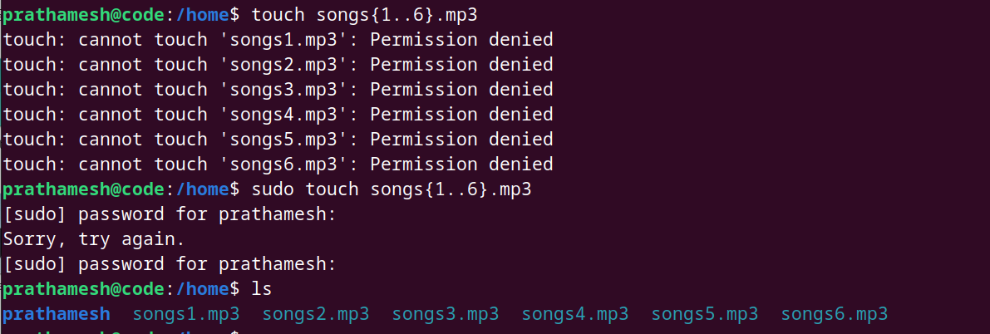

* Create 6 files with names of the form snapX.jpg.

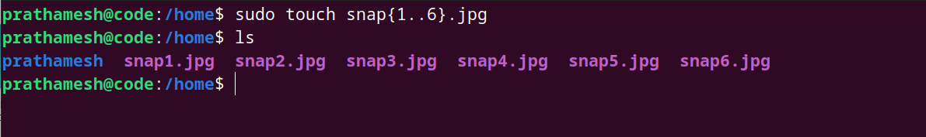

* Create 6 files with names of the form filmX.avi.

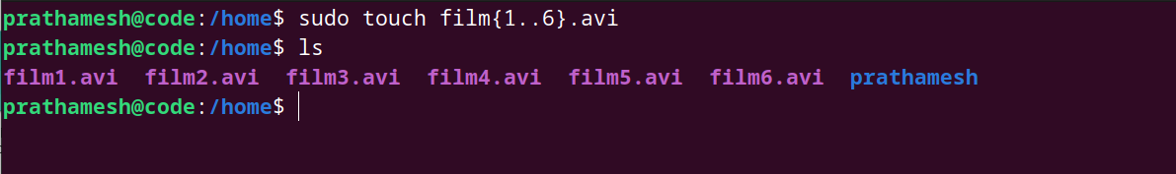

In each set, replace X with the numbers 1 through 6.

2. From your home directory,

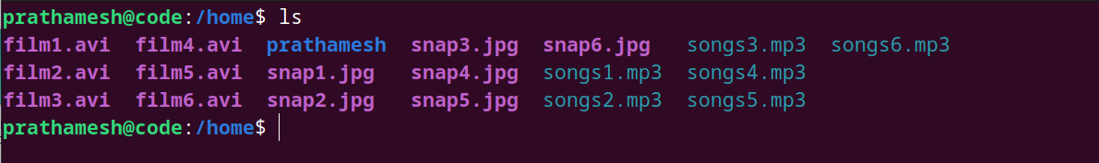

* Move songs file into your Music subdirectory.

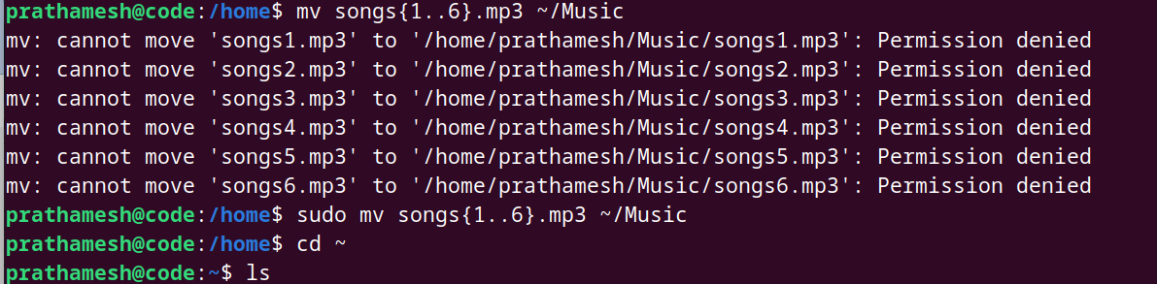



* Move snap file into your Pictures subdirectory.

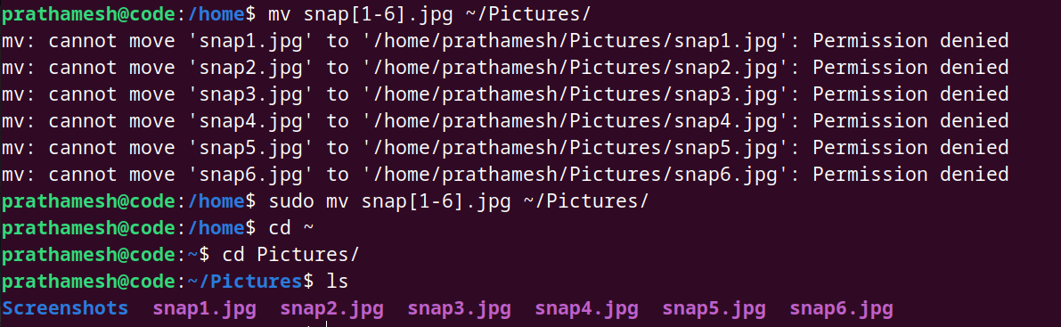

* Move your movie files into Videos subdirectory

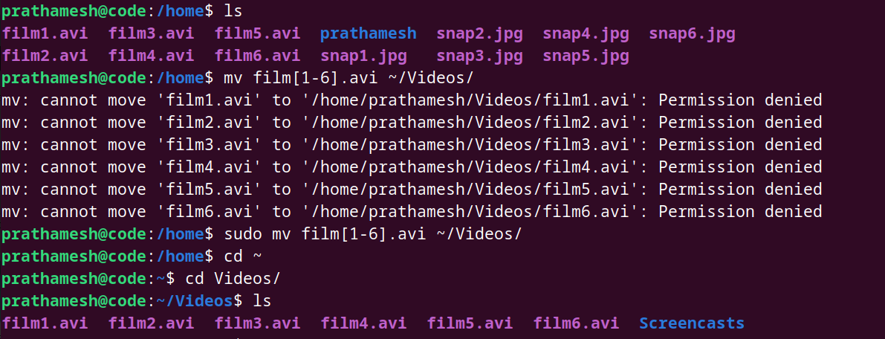

3. Create 3 subdirectories for organizing your files named friends,family,work

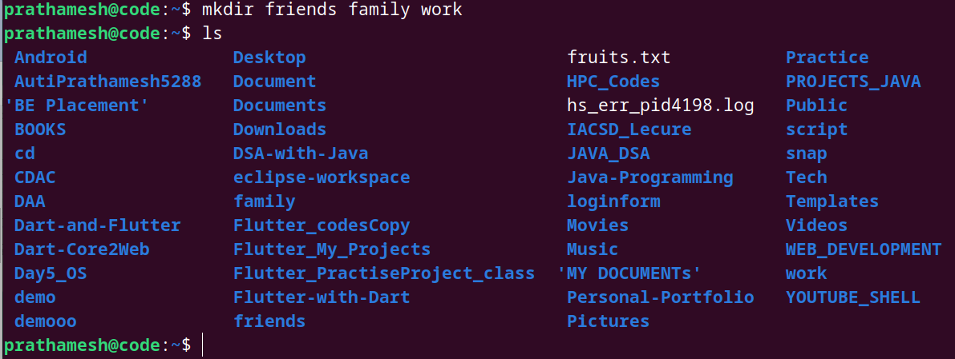

4. Copy files (all types ) containing numbers 1 and 2 to the friends folder.





Copy files (all types) containing numbers 3 and 4 to the family folder.

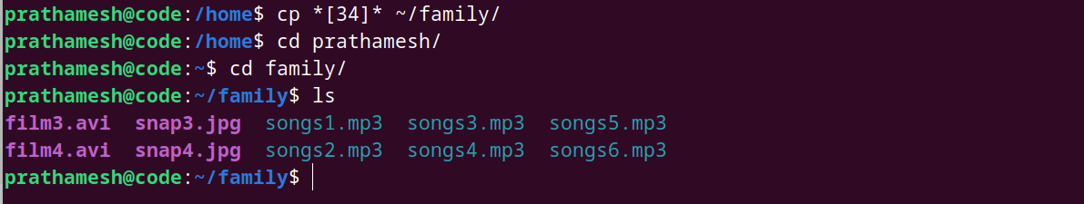

Copy files (all types) containing numbers 5 and 6 to the work folder.

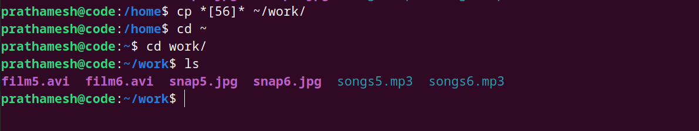

6. Delete all files in family subdirectory.



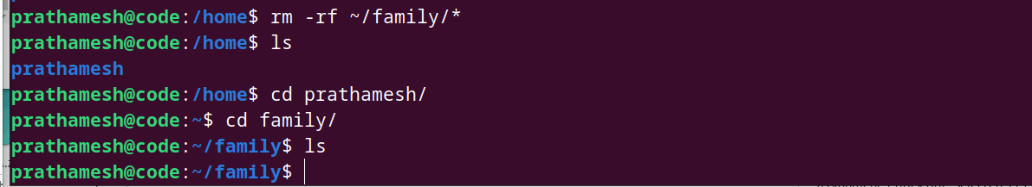

7. Delete friends subdirectory

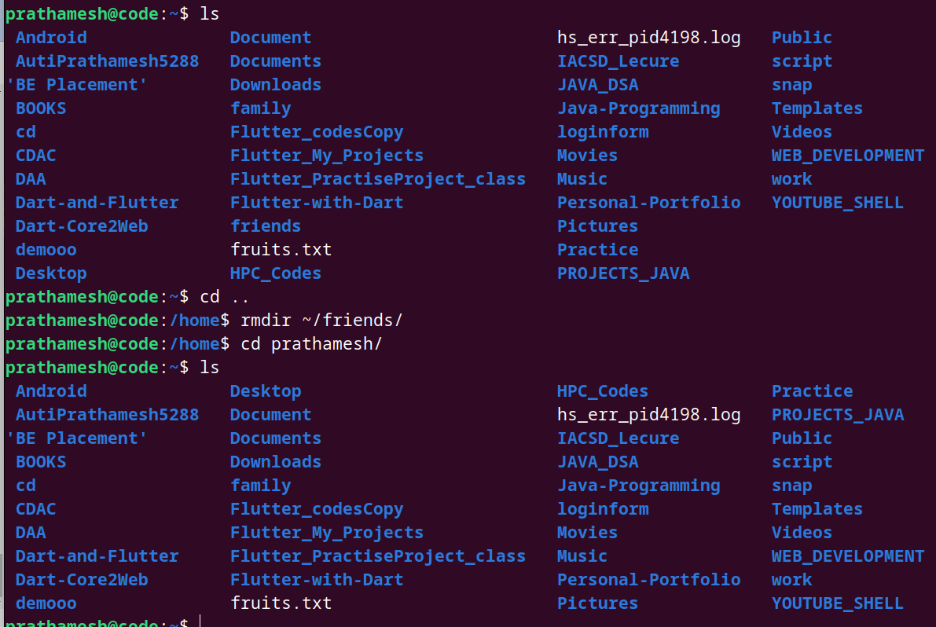

8. Create user tom , bob , sam , prince

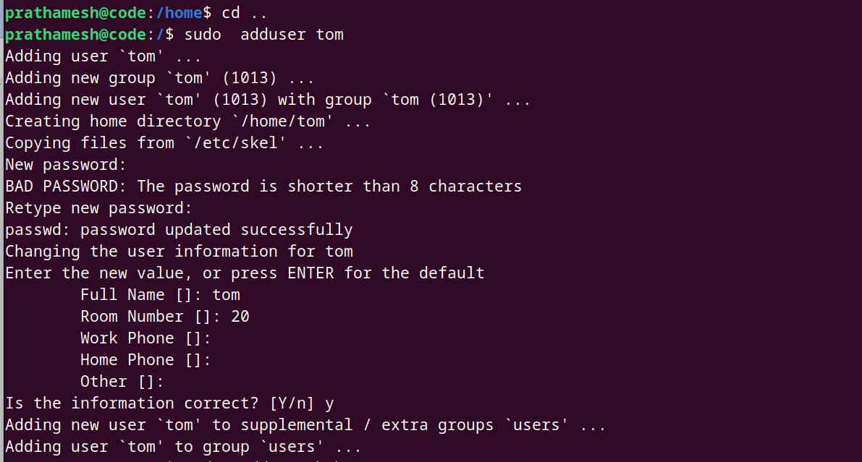

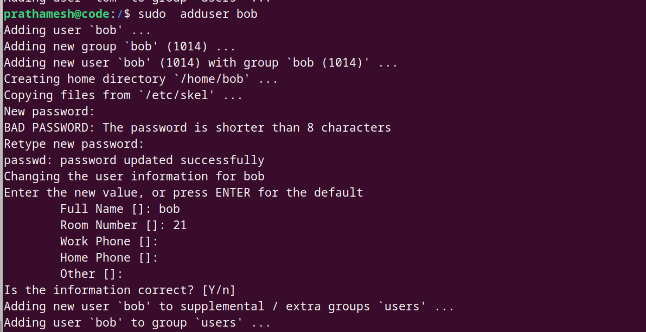

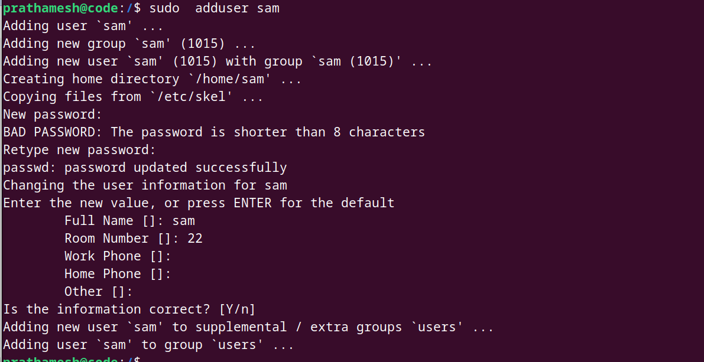

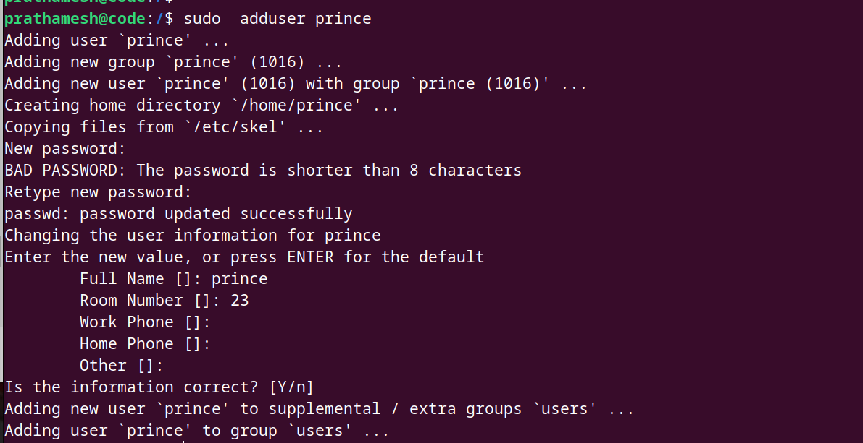

9. Create Group dac , dbda ,ditiss

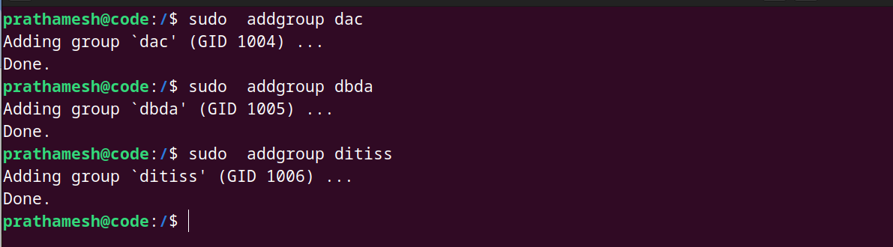

10. add user

Tom in dac





Bob in dbda

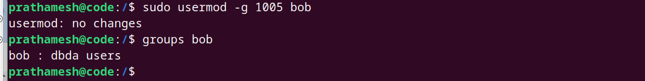

Sam in ditiss

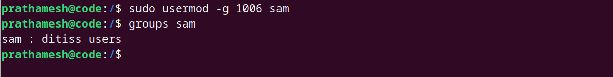

11. login as prince and create iacsd directory in /tmp and create 4 files in iacsd with name project-1 project-2 upto 4

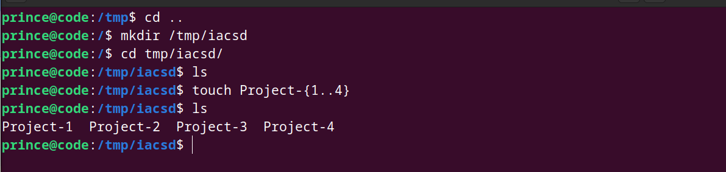

12. assign permissions to project files as below

Project-1 – tom should be owner of this

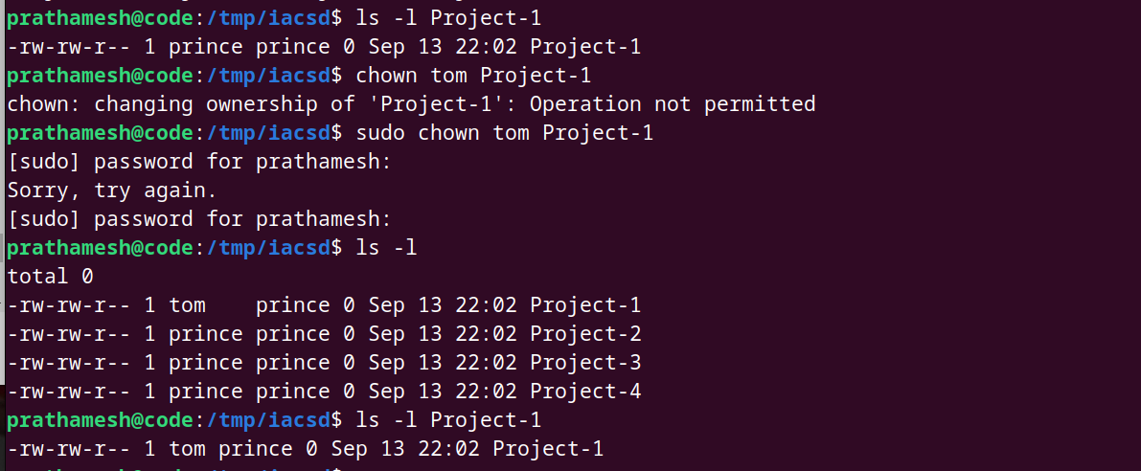

Project-2 – dac should be owner of this

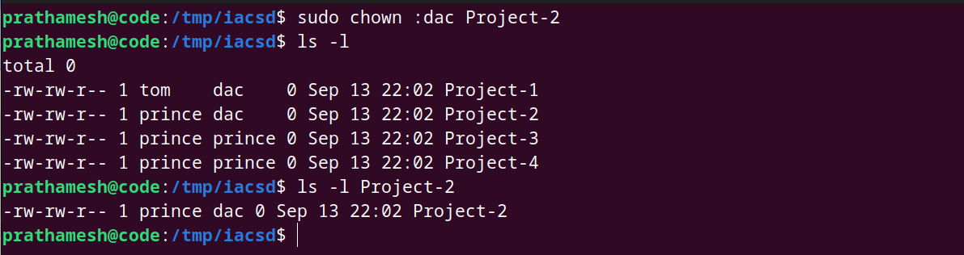

Project-3 --- others should not have any permission but tom should have rw access

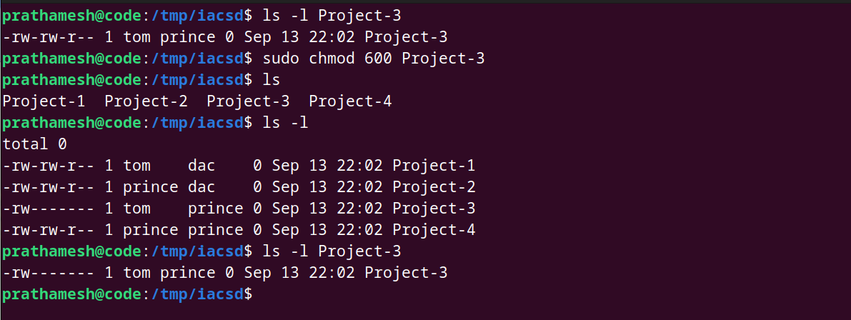

Project-4 – dbda group should have rwx permissions.

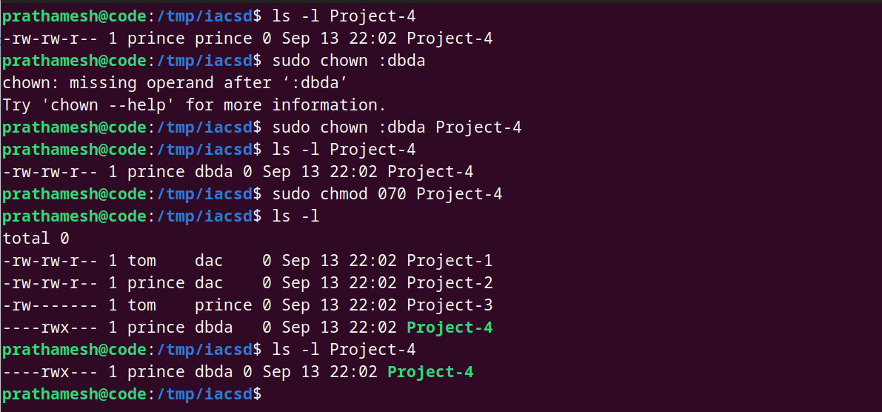

**Assignment -2**

* Explain telnet,ftp,ssh commands.

### ****Telnet****

Telnet is one of the oldest protocols used to access remote systems, providing a command-line interface (CLI) to control a device or computer. When you establish a Telnet session, you're essentially opening a "terminal" into the remote machine, where you can execute commands as if you were physically present. The process is straightforward: you specify the IP address or hostname of the target device and initiate a connection. Once connected, you'll be prompted to enter a username and password. However, because Telnet lacks encryption, all the data you send—including login credentials—can be intercepted by anyone monitoring the network. Therefore, Telnet is rarely used over the internet and is mainly reserved for internal network use or specialized tasks where security is less of a concern.

### ****FTP****

FTP is a protocol designed specifically for transferring files between systems. With an FTP connection, you can upload, download, delete, or modify files on a remote server. When using FTP, you connect to an FTP server, provide login credentials (or use anonymous access), and then interact with the files on the server. FTP can transfer large files and directories, making it useful for website hosting and management. However, similar to Telnet, FTP sends data in plain text, which poses a security risk. To mitigate this, more secure versions like **FTPS** (FTP over SSL/TLS) or **SFTP** (which operates over SSH) are commonly used when transferring files over untrusted networks, such as the internet.

### ****SSH****

SSH is a secure alternative to Telnet, providing encrypted connections for remote access and file transfers. With SSH, all communications between the client and server, including login credentials and commands, are encrypted, ensuring privacy and security. SSH is widely used for managing remote systems because it allows not only command execution but also tunneling, file transfers (via SCP and SFTP), and secure forwarding of ports. In practice, you connect to a remote machine using its IP address or domain, authenticate yourself using either a password or an SSH key, and then gain access to the remote terminal. The encrypted nature of SSH makes it ideal for use over public or untrusted networks, such as the internet.

* Create a file commands.txt . write linux commands in it .

1. ls - List directory contents

2. cd - Change directory

3. pwd - Print working directory

4. mkdir - Create a new directory

5. rm - Remove files or directories

6. cp - Copy files or directories

7. mv - Move or rename files or directories

8. cat - Concatenate and display file contents

9. touch - Create an empty file or update the timestamp of a file

10. chmod - Change file permissions

11. chown - Change file owner and group

12. grep - Search for patterns in files

13. find - Search for files in a directory hierarchy

14. tar - Archive files and directories

15. ps - Display currently running processes

16. kill - Terminate a process by PID

17. df - Display disk space usage

18. du - Display file and directory size

19. man - Display manual for a command

20. echo - Print text to the terminal or write to a file

21. wget - Download files from the internet

22. ssh - Secure Shell for remote login

23. scp - Secure copy for file transfer

24. ftp - File Transfer Protocol client

25. sudo - Execute a command as another user (usually root)

26. whoami - gives current user name

27. ls -a - list all hidden files

28. alias - for giving nick name

29. nano - text editor

30. ping - used for network checking

31. sort -r - sorting content of file in reverse order

* Count words in that file. Sort contents of file in reverse order.  
  search the word “ls” in this file .

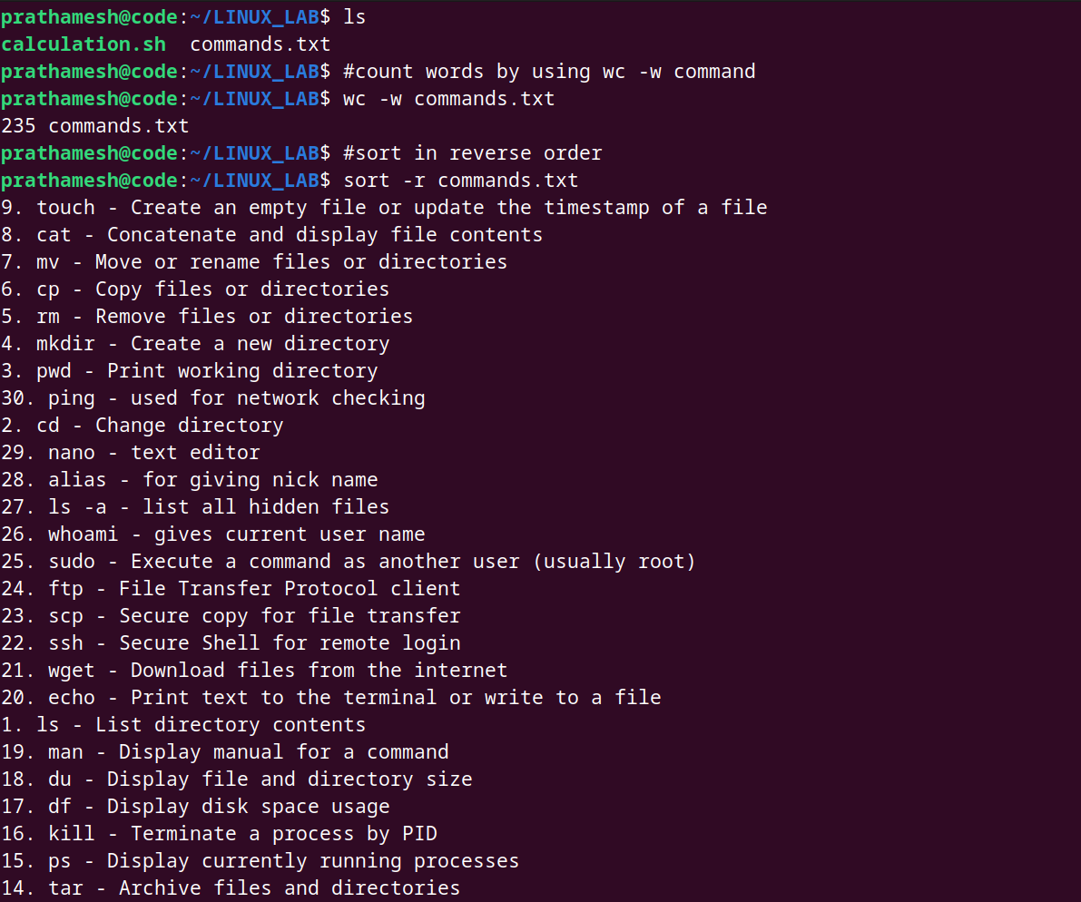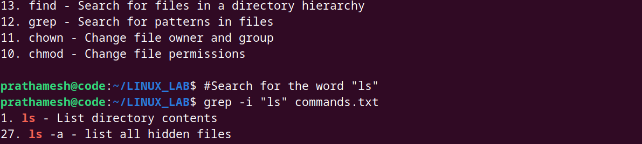

* [count the number of lines](http://man7.org/linux/man-pages/man1/wc.1.html) in the file that contain "pwd”



* Write a command that do not display lines containing “dbda”.

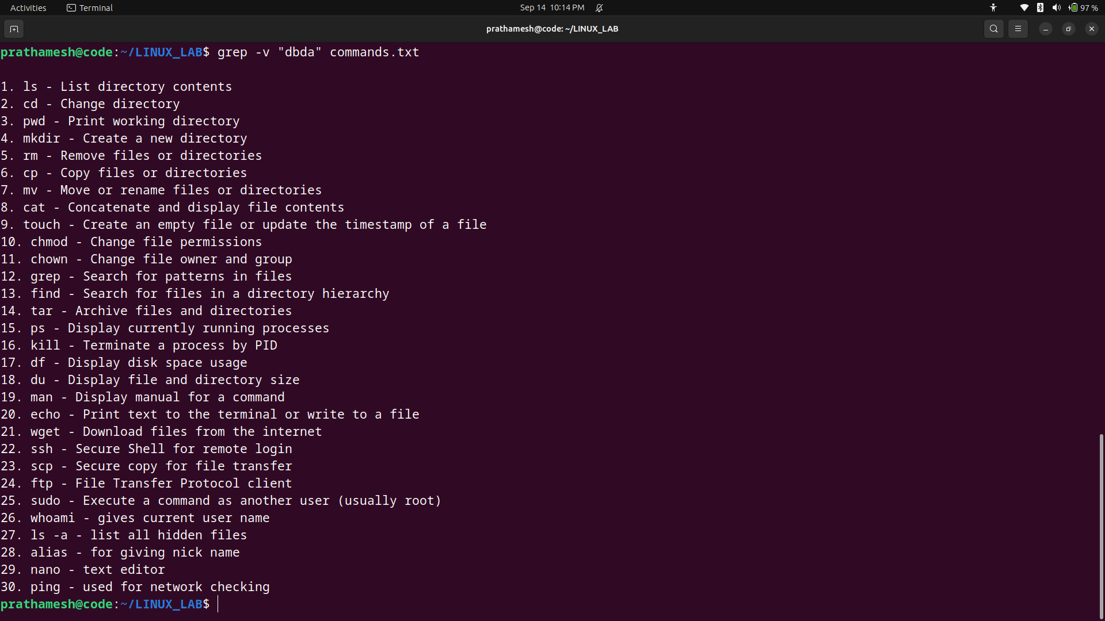

* List all files and directories and give them as input to `grep` command using

piping store in file.txt

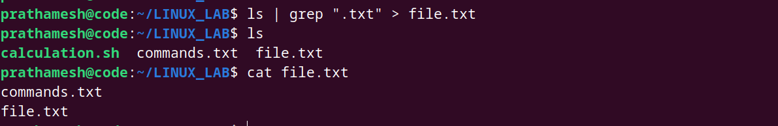

* Sort file.txt

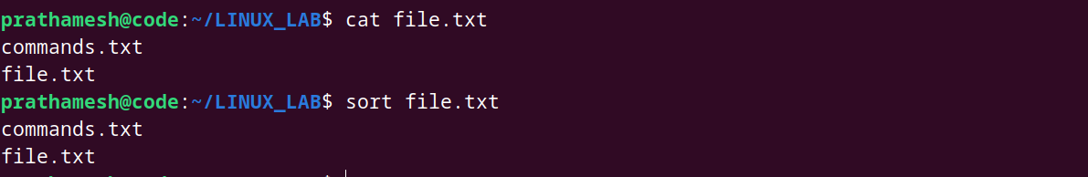

* Write a Shell Script to find maximum between three numbers.

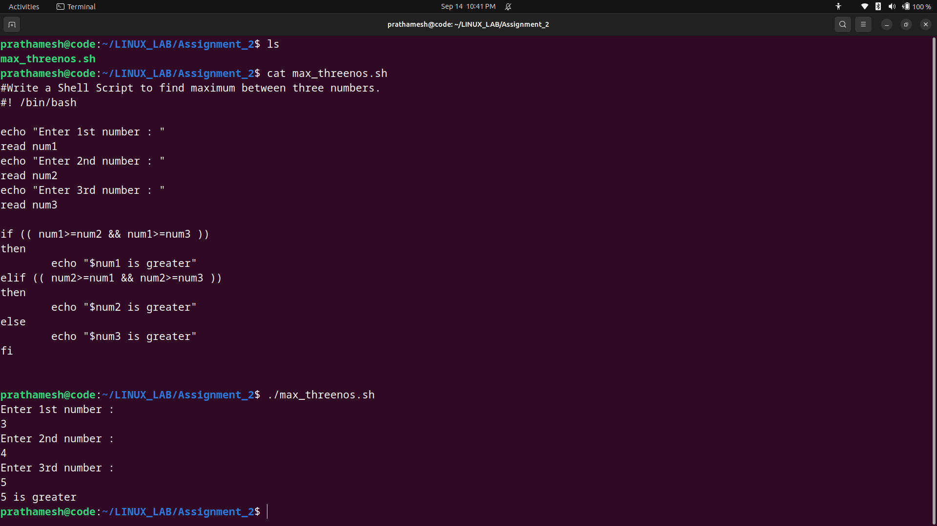

* Write a Shell Script to ch­eck whether a number is negative, positive or zero.

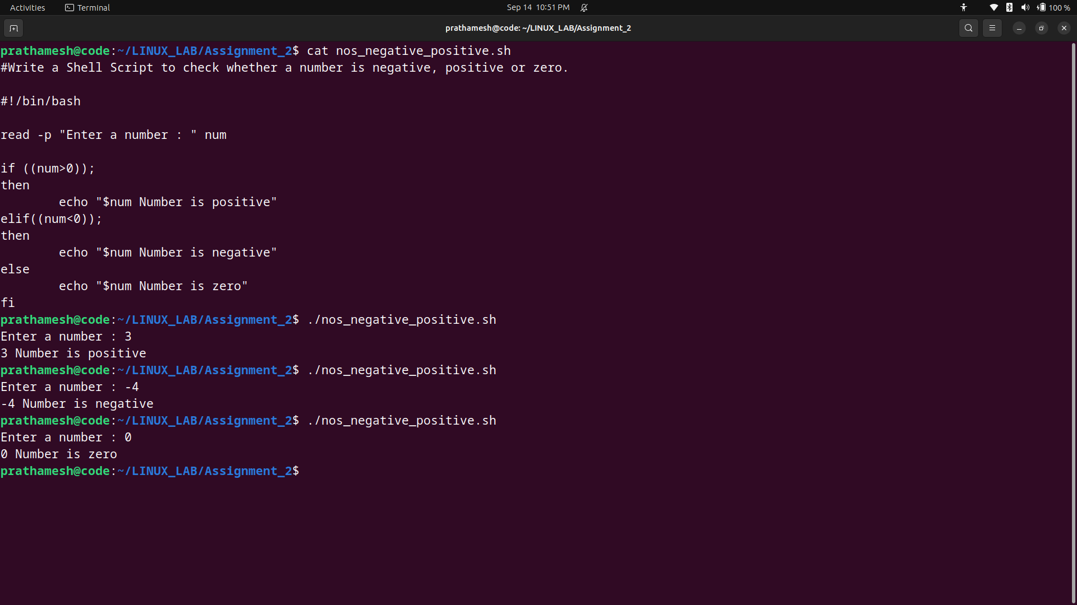

* Write a Shell Script to check whether a number is divisible by 5 and 11 or not.

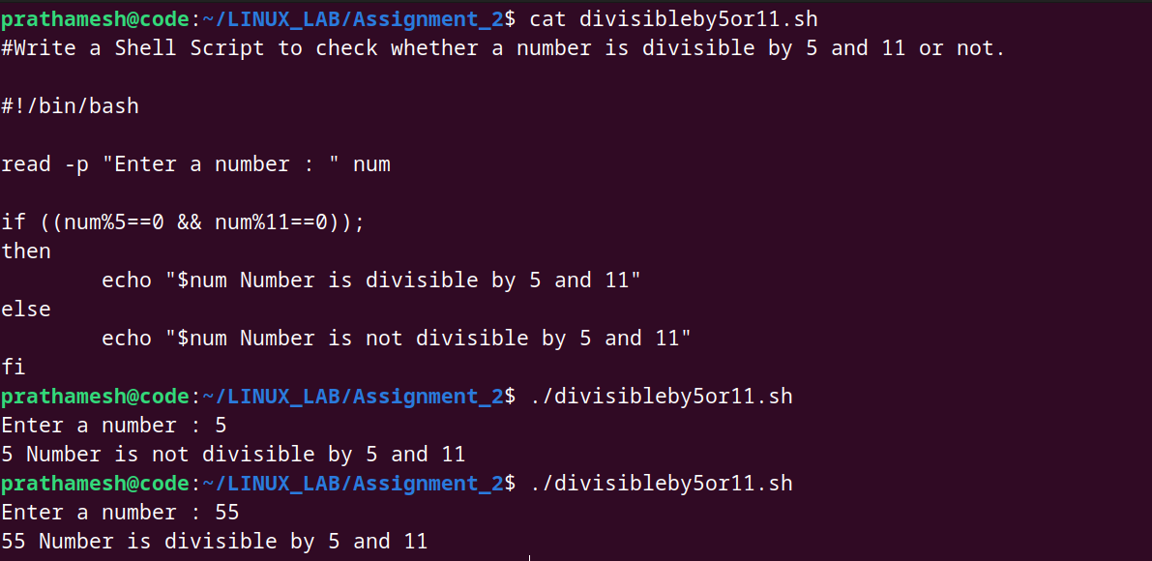

* Write a Shell Script to check whether a number is even or odd.

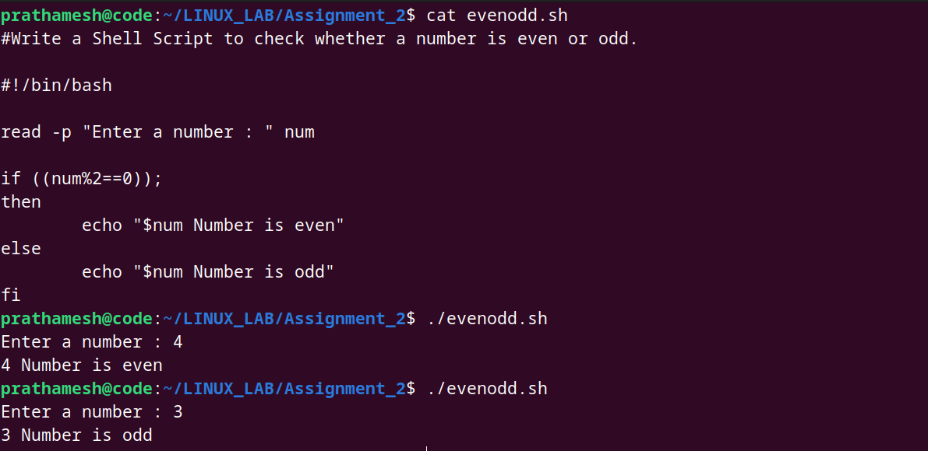

* Write a Shell Script to check whether a year is leap year or not.

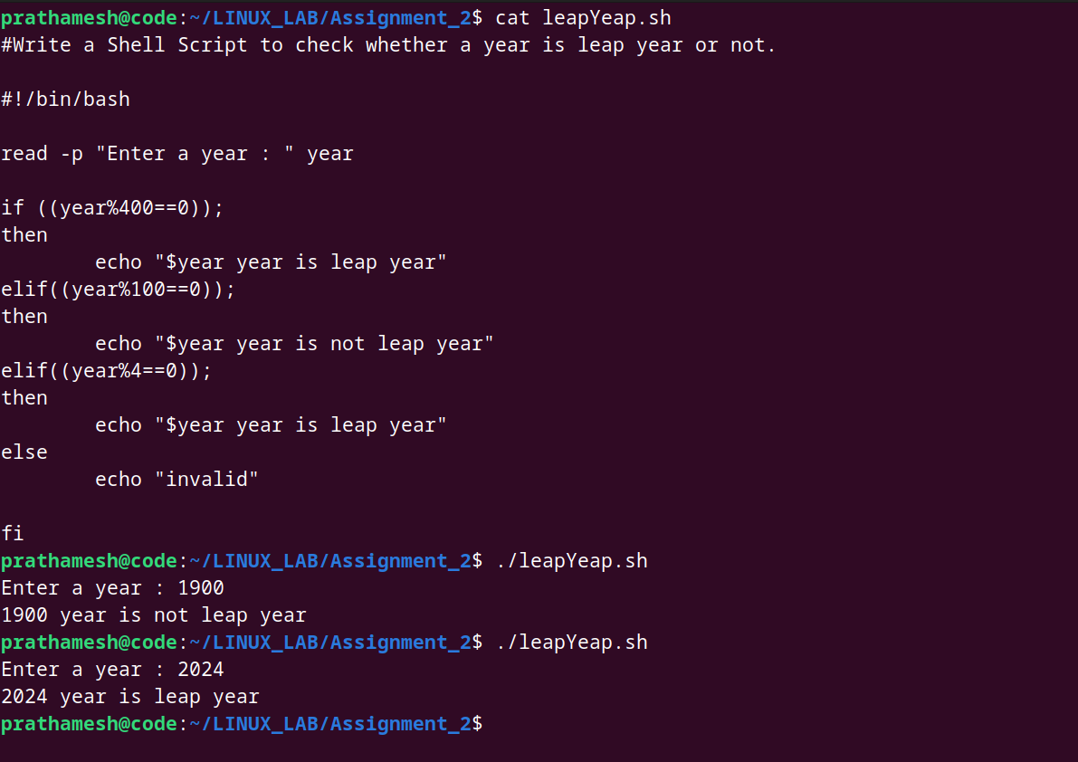

* Write shell script to check eligibility of candidate for voter id card

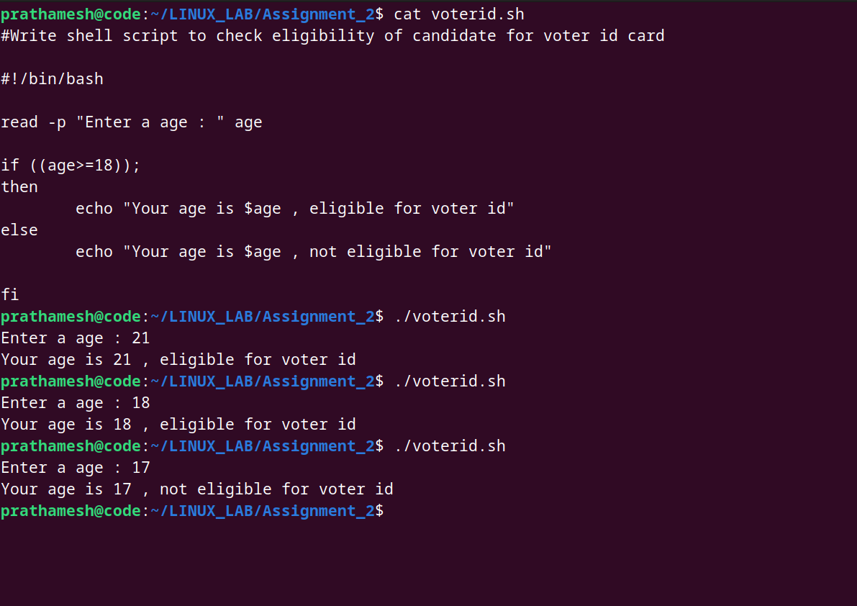

* Shell Script to display the first 10 natural numbers.

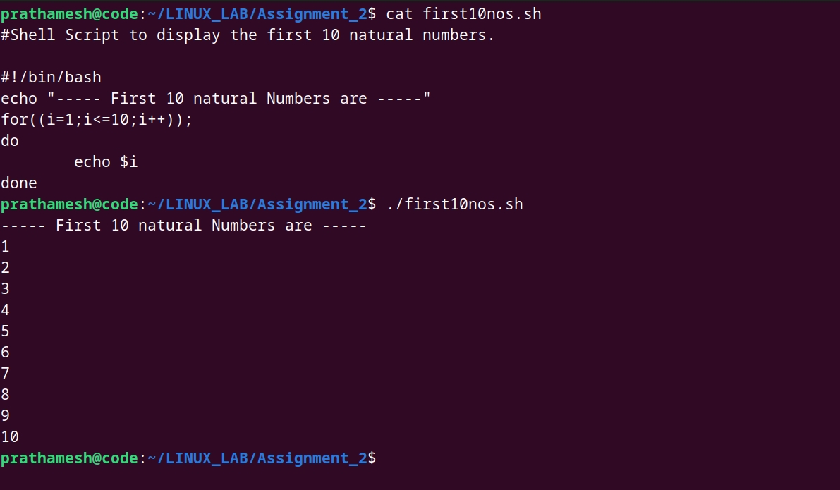

**Assignment -3**

**Create a file “calculation.sh” . Write a shell script to print**

* your are logged in as which user
* in which directory you are
* and in which terminal you are working
* total number of files and directories in current directory
* get access control list of file.
* Give permission to read and write to user “user1” for file .
* Give permission to read to group “dac” for file .

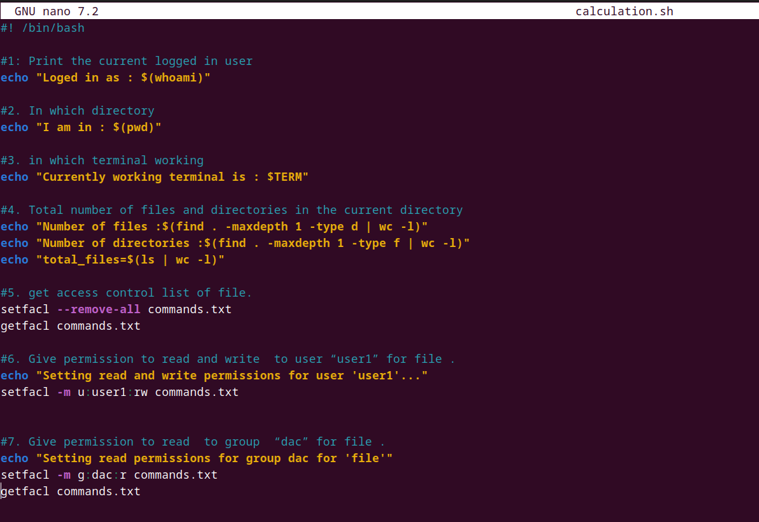

OUTPUT :

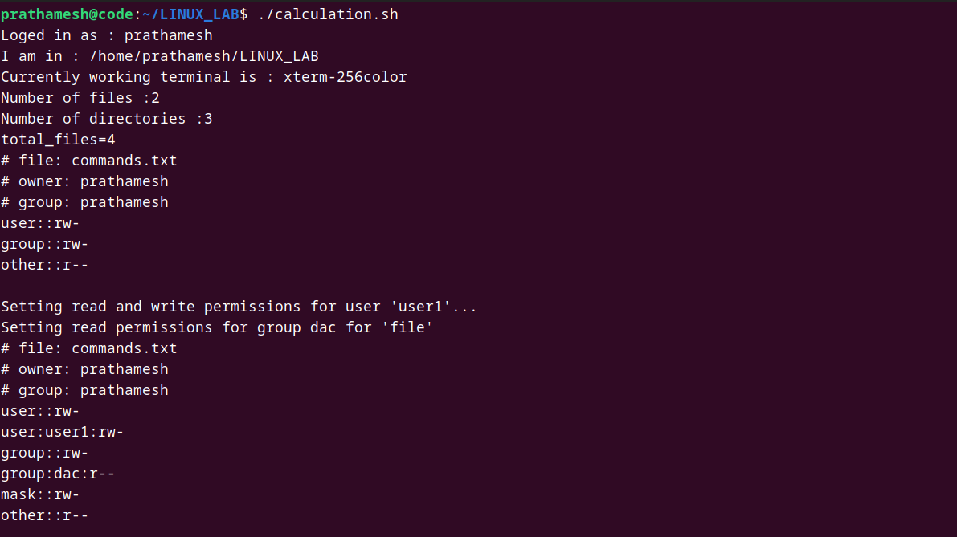

**Assignment-4**

* Write a Shell Script to find maximum between three numbers.



* Write a Shell Script to ch­eck whether a number is negative, positive or zero.



* Write a Shell Script to check whether a number is divisible by 5 and 11 or not.



* Write a Shell Script to check whether a number is even or odd.



* Write a Shell Script to check whether a year is leap year or not.



6. Shell Script to print number between 1 to 10 in character format using switch-case.

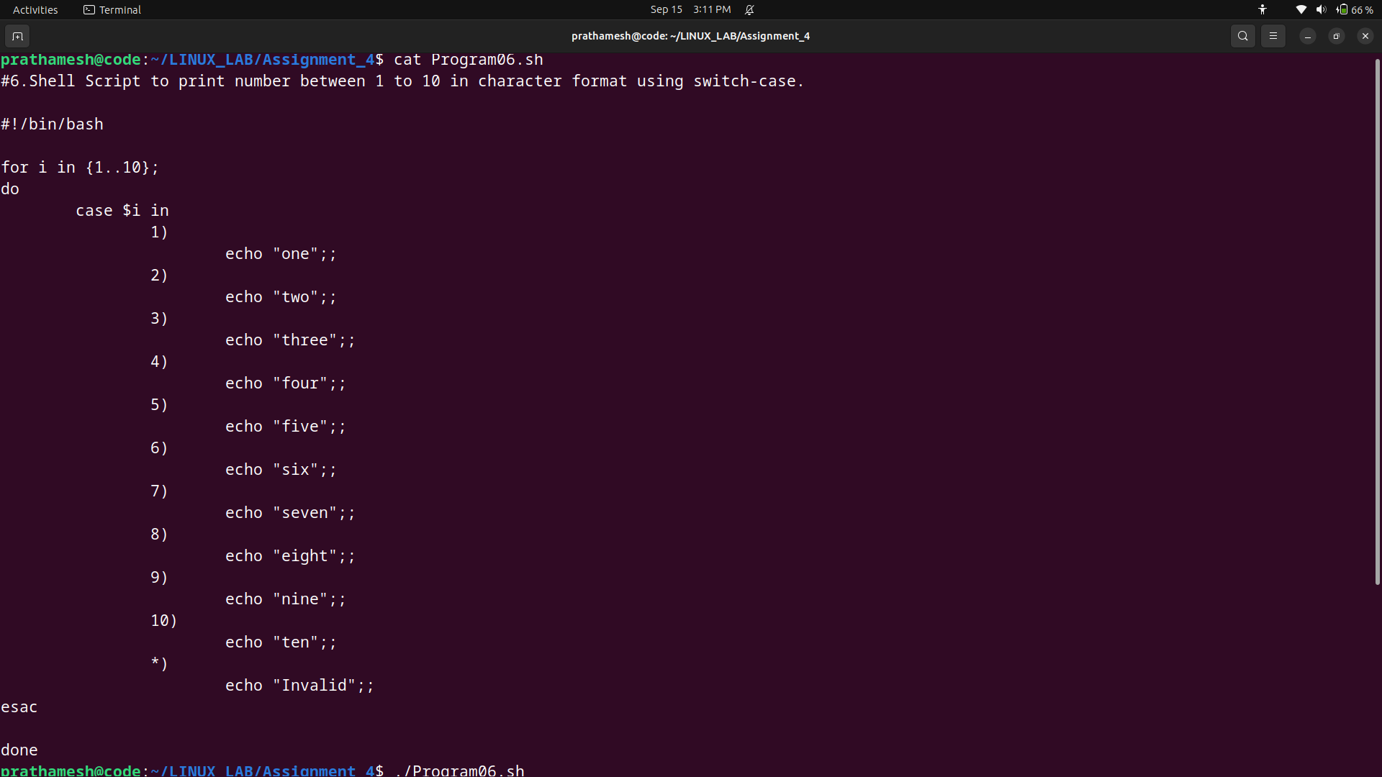

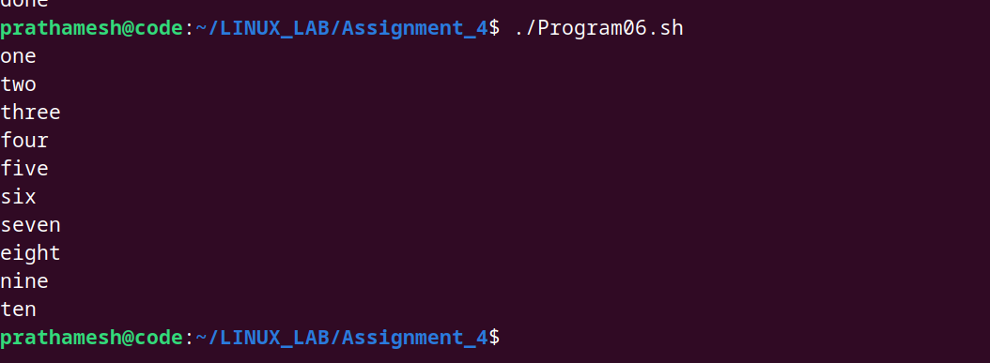

7. Shell Script to accept id from user to confirm department using switch-case.

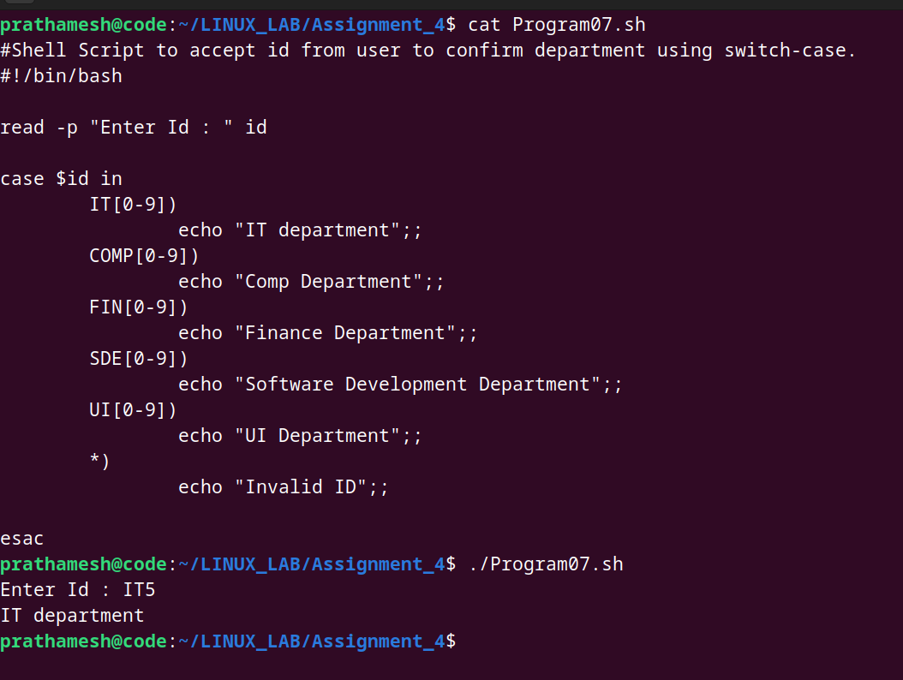

8. Shell Script to check password is correct or incorrect using switch-case.

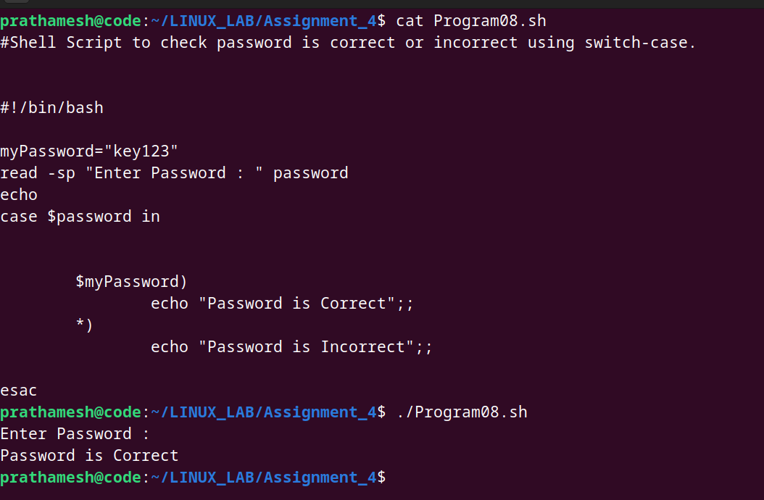

9. Shell Script to print day of week using switch-case.

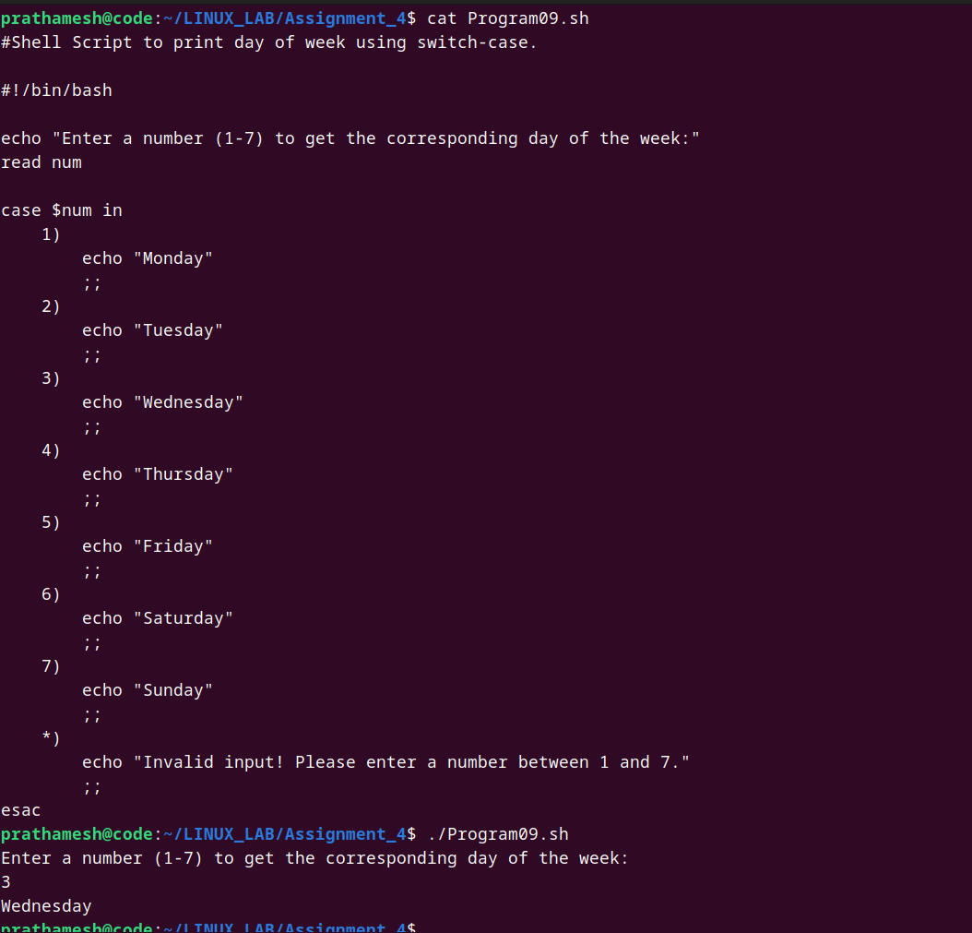

10. Shell Script to create calculator using switch-case.

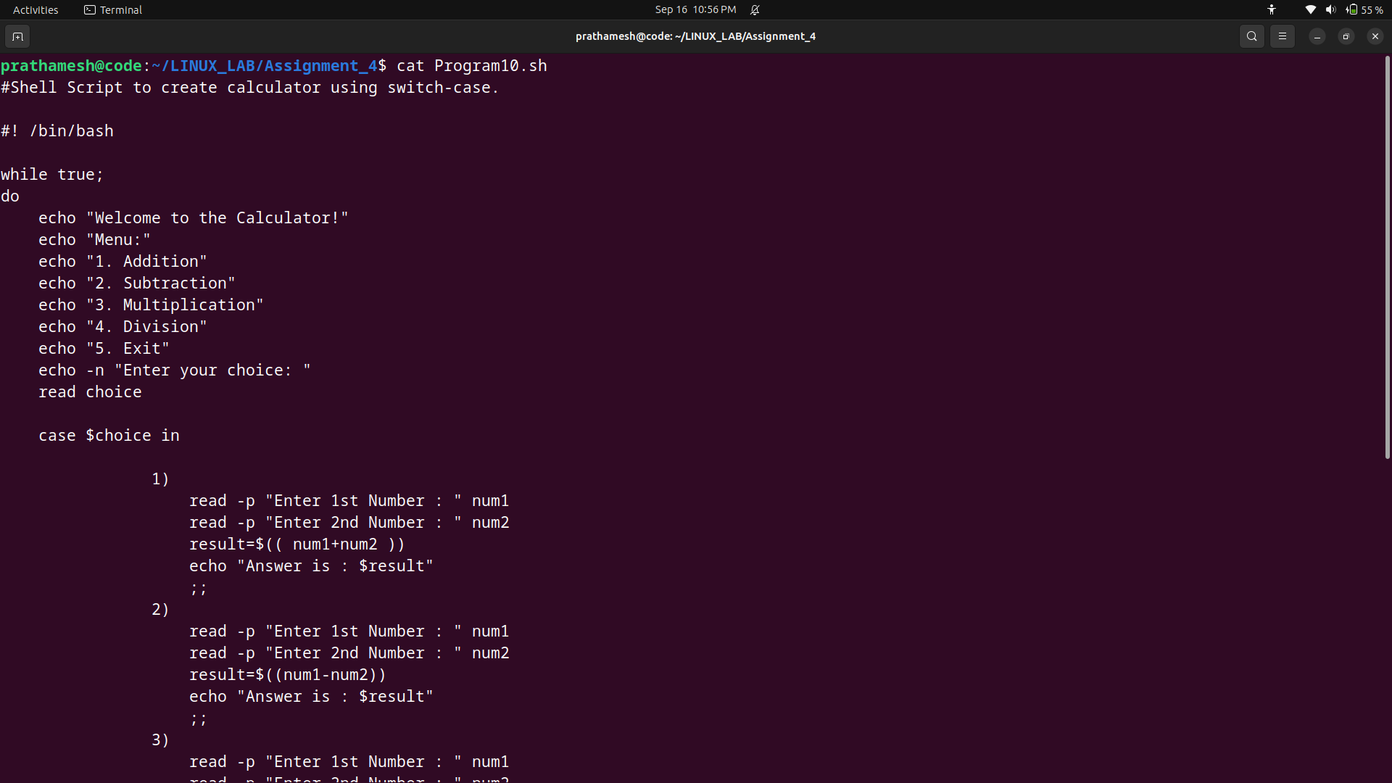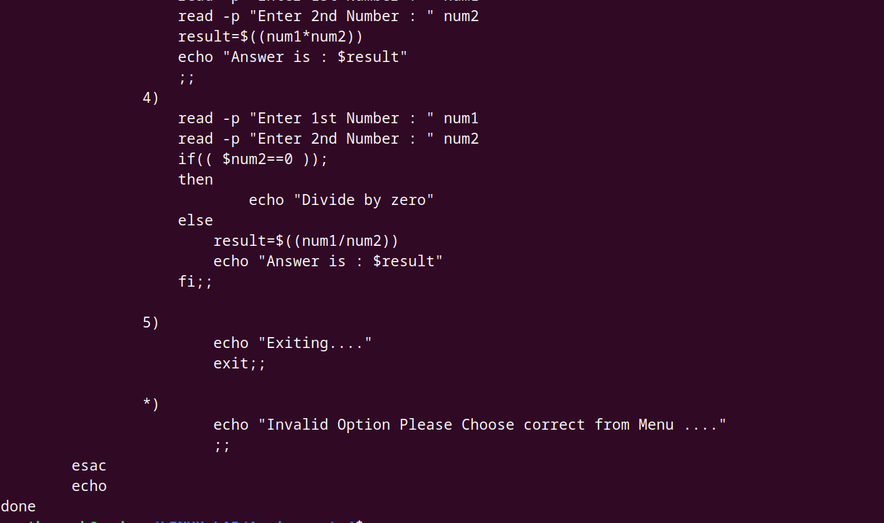

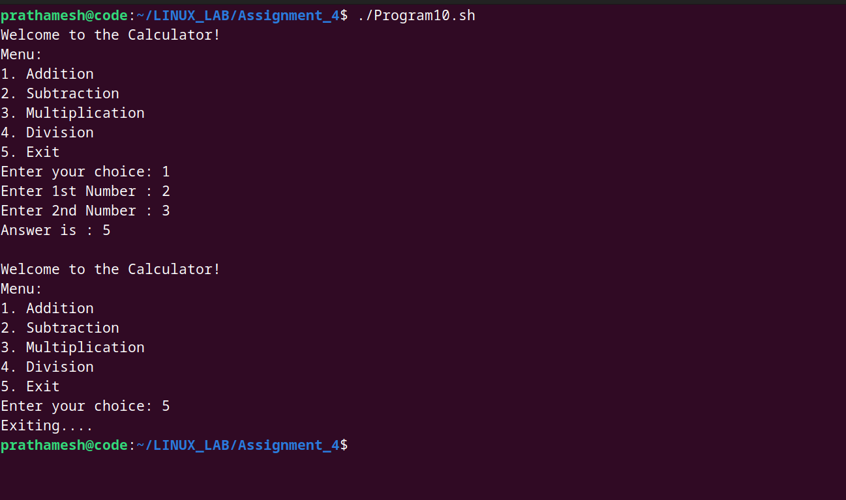

11. Write a shell script to create a menu driven program for adding, deletion or finding a record in a database. Database should have the field like rollno, name, semester and marks of three subjects. Last option of the menu should be to exit the menu.

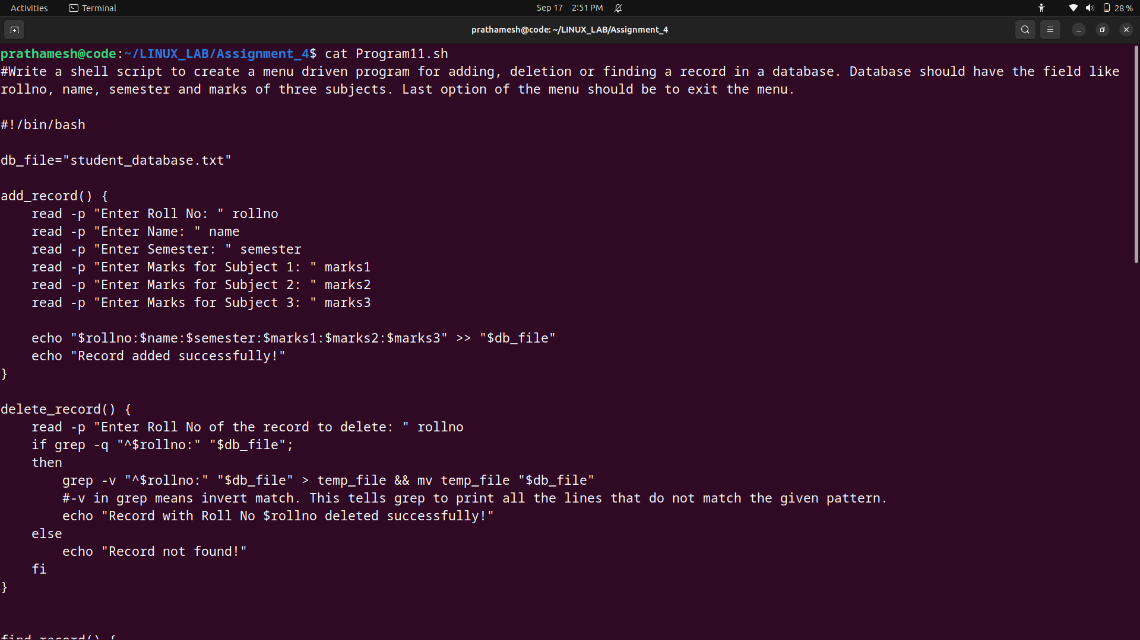

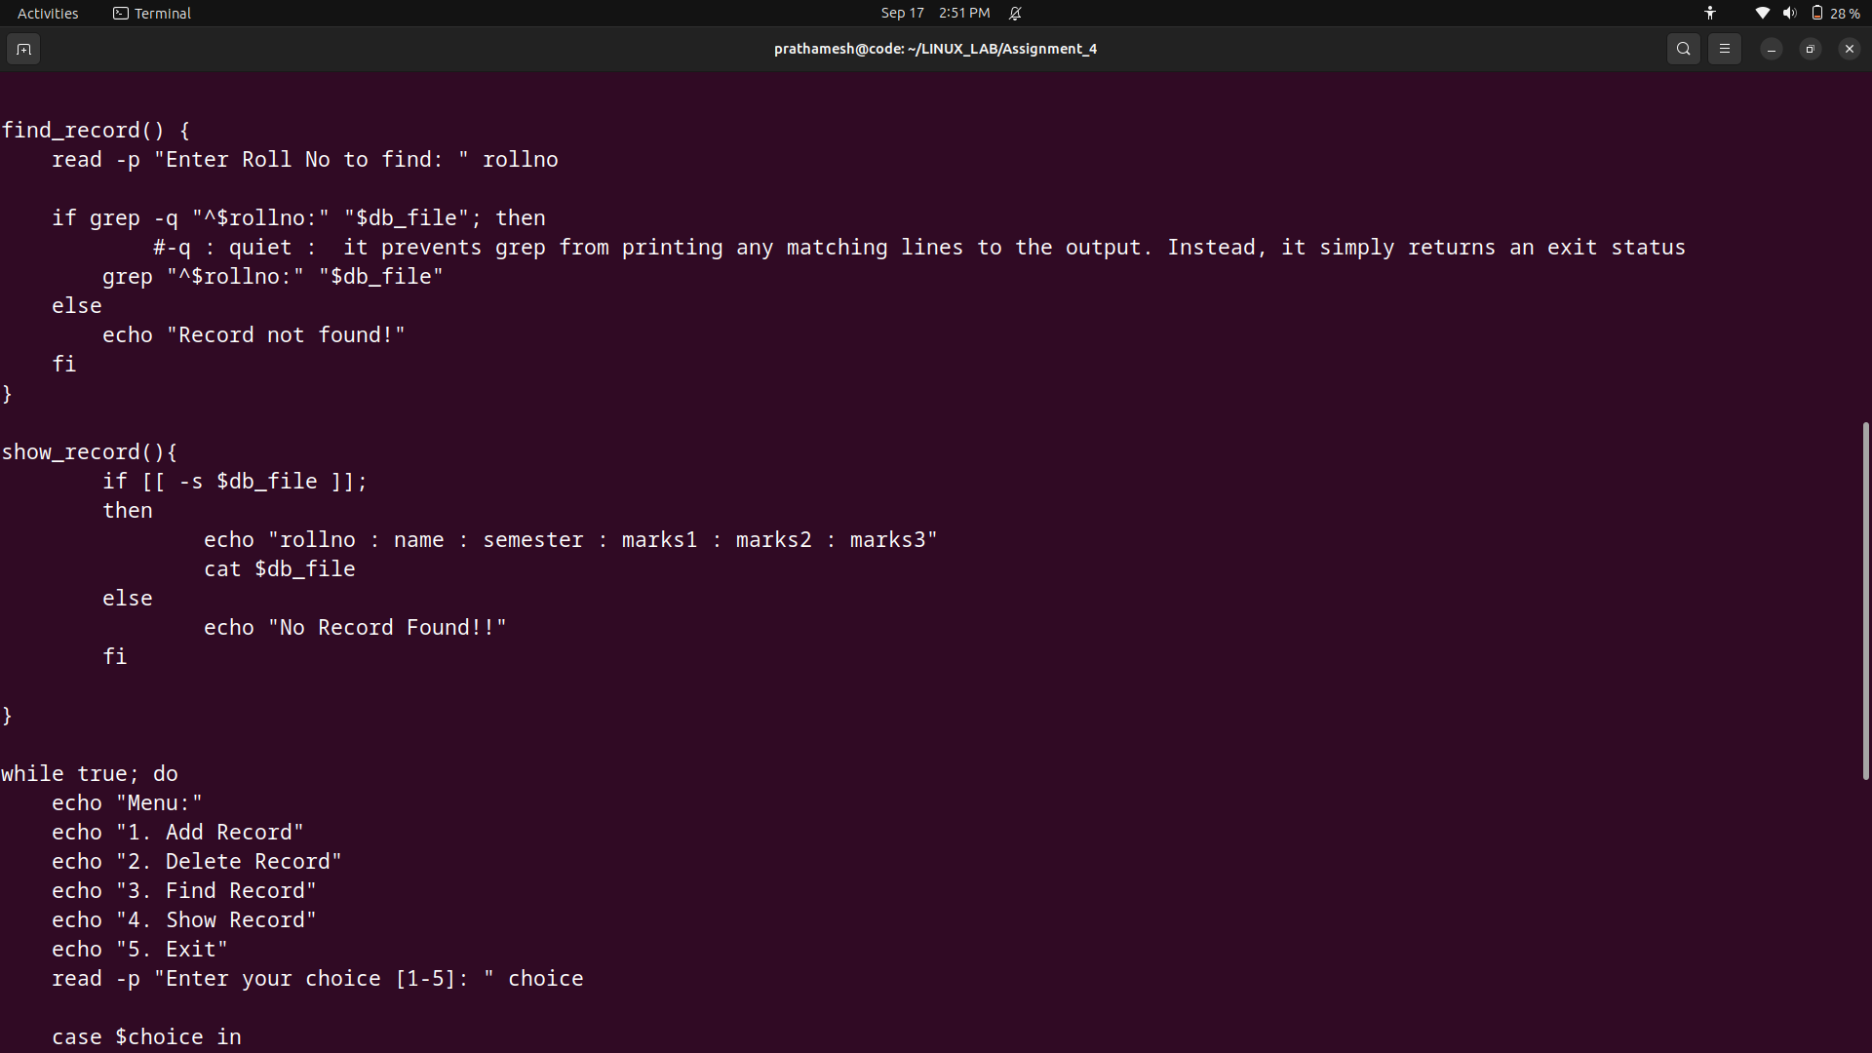

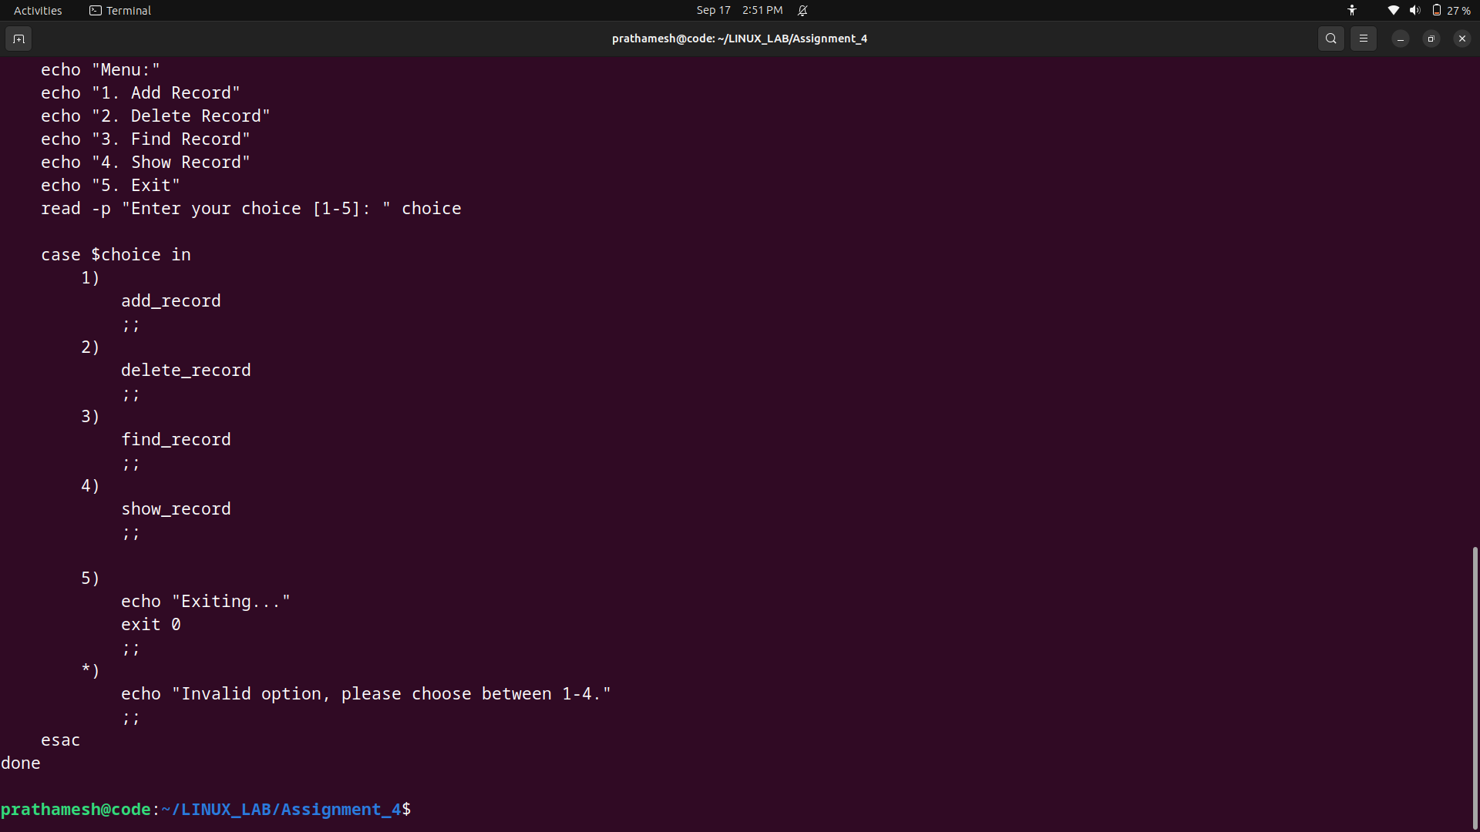

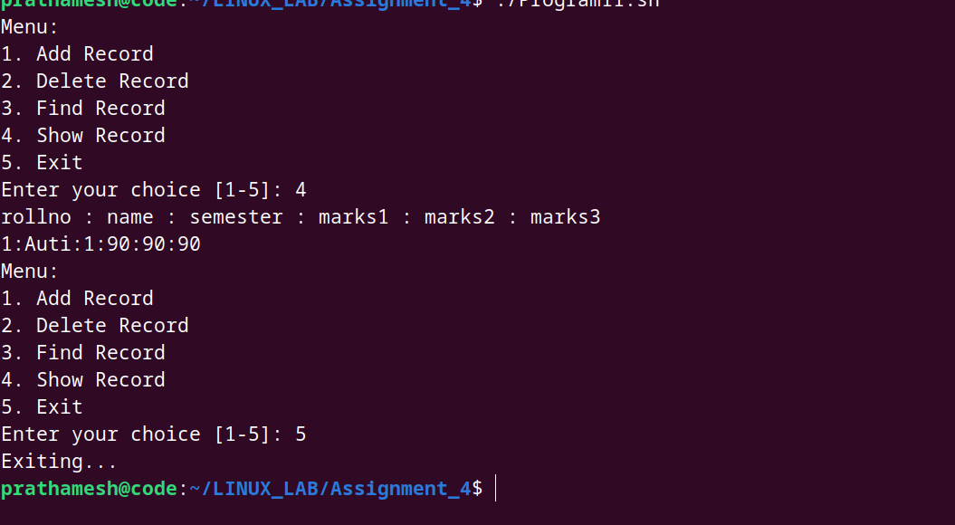

12. Write a Linux shell script to accept 10 number and tell how many are +tive, -tive and zero.

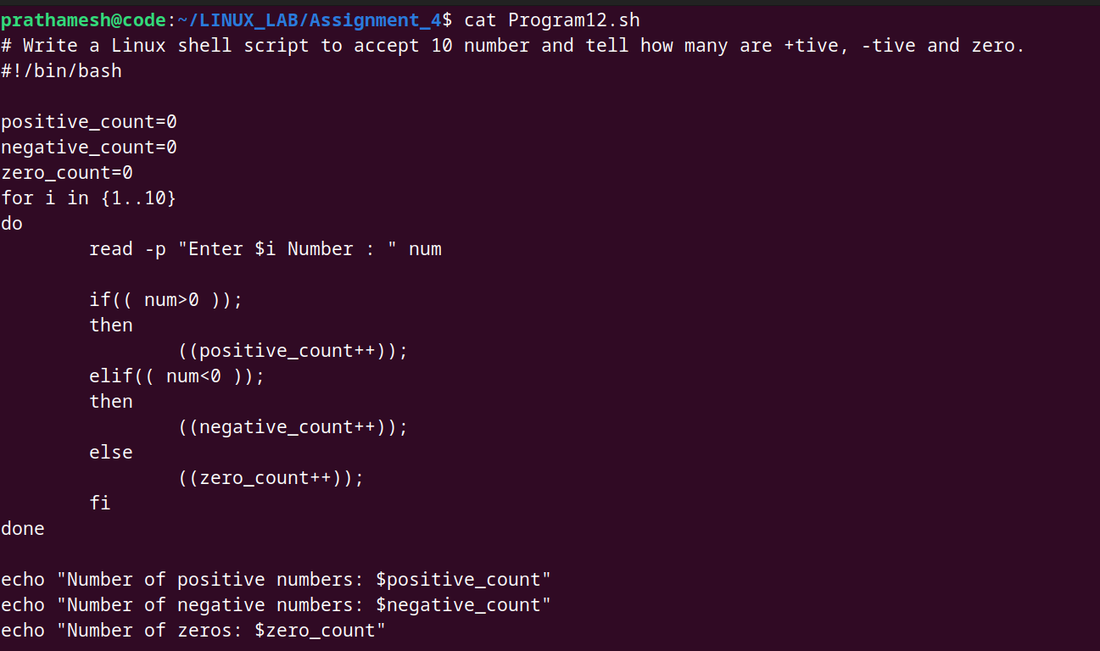

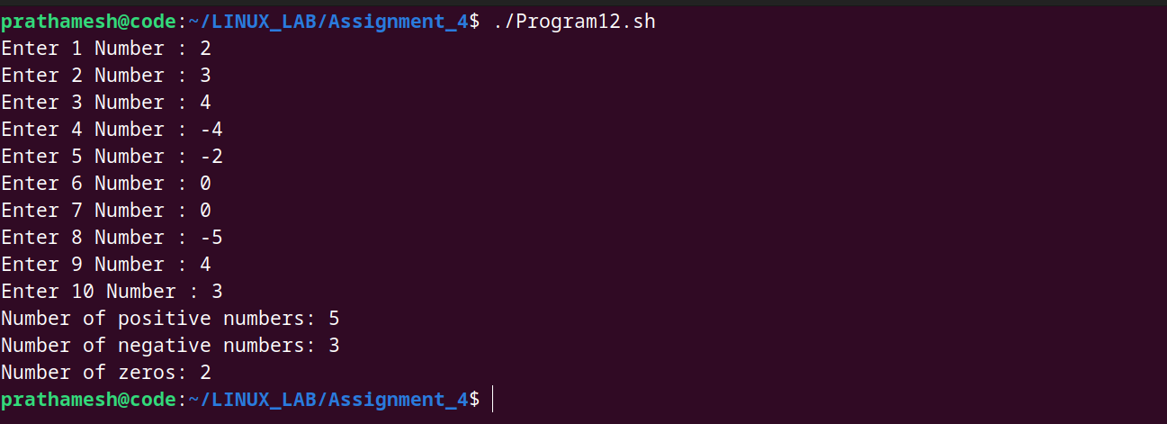

13. Write a shell slcript to accept five number and display max and min value.

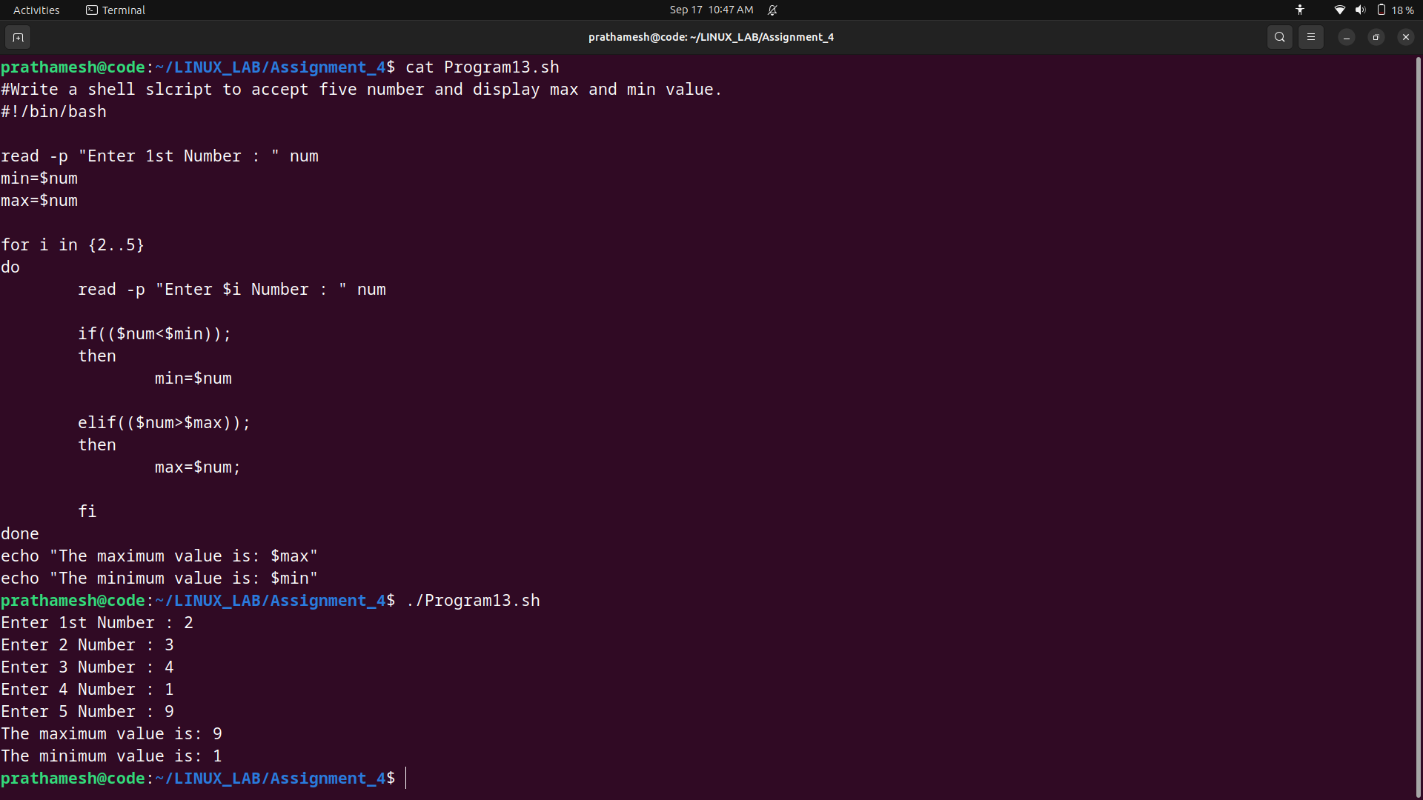

14. Write a script to find out String is palindrome or not.

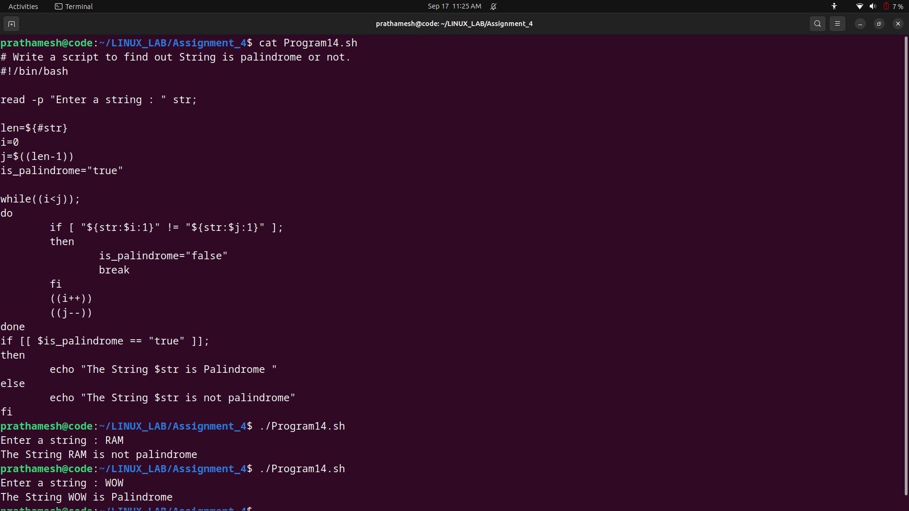

15. Write a shell script to print given number’s sum of all digits (eg. If number is 123, then it’s sum of all digits will be 1+2+3=6)

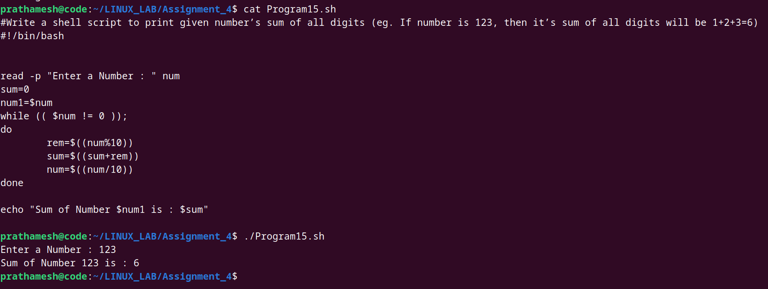

16. Create a script to Create user , Delete user , Create group , delete Group using case

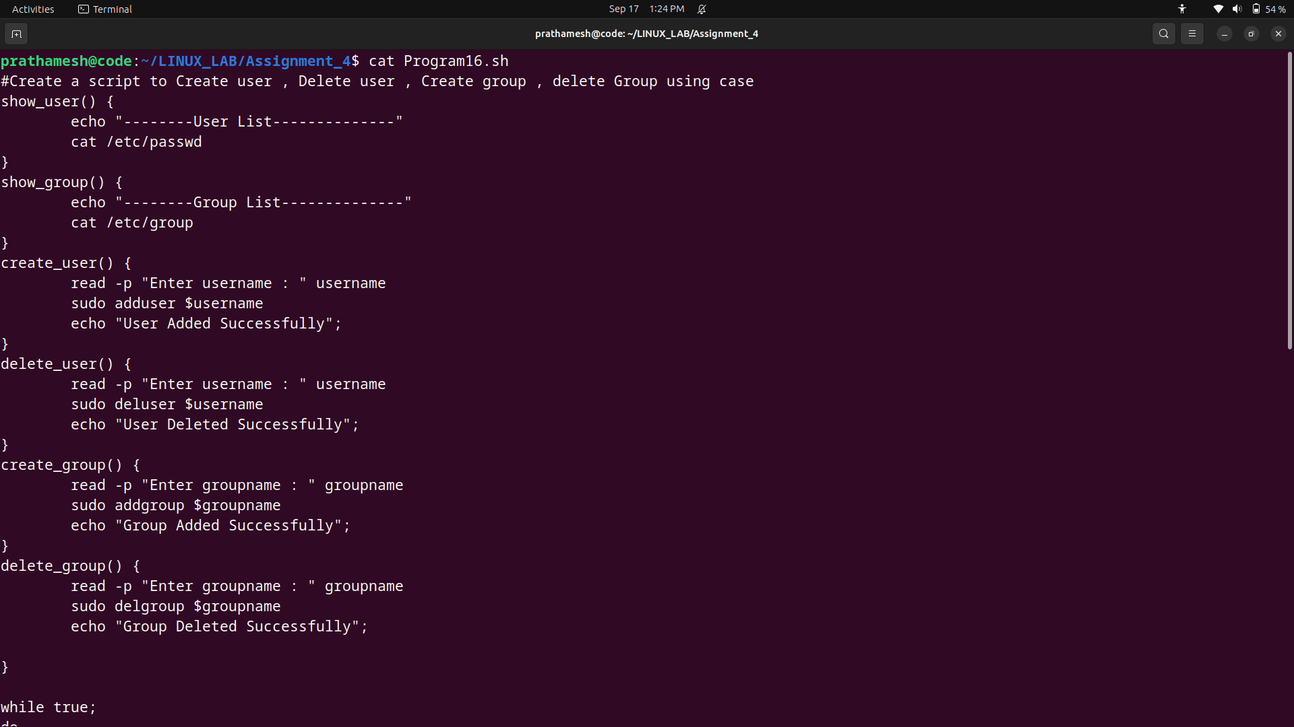

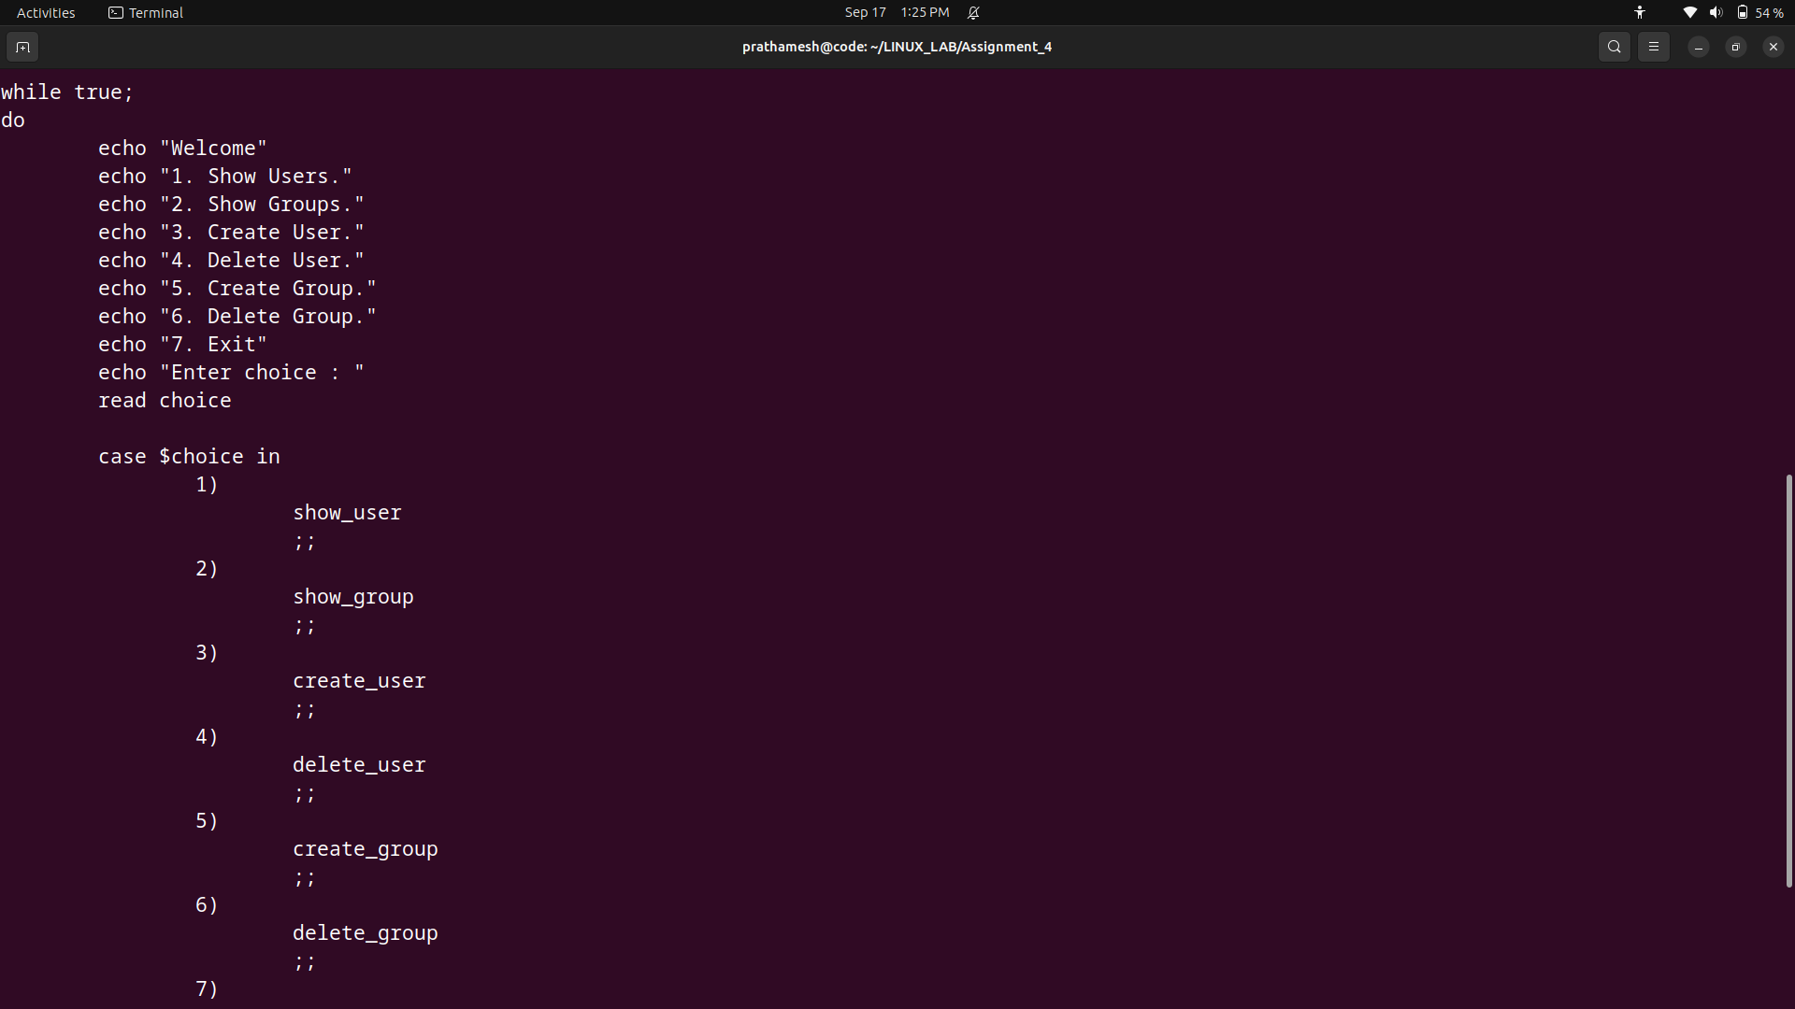

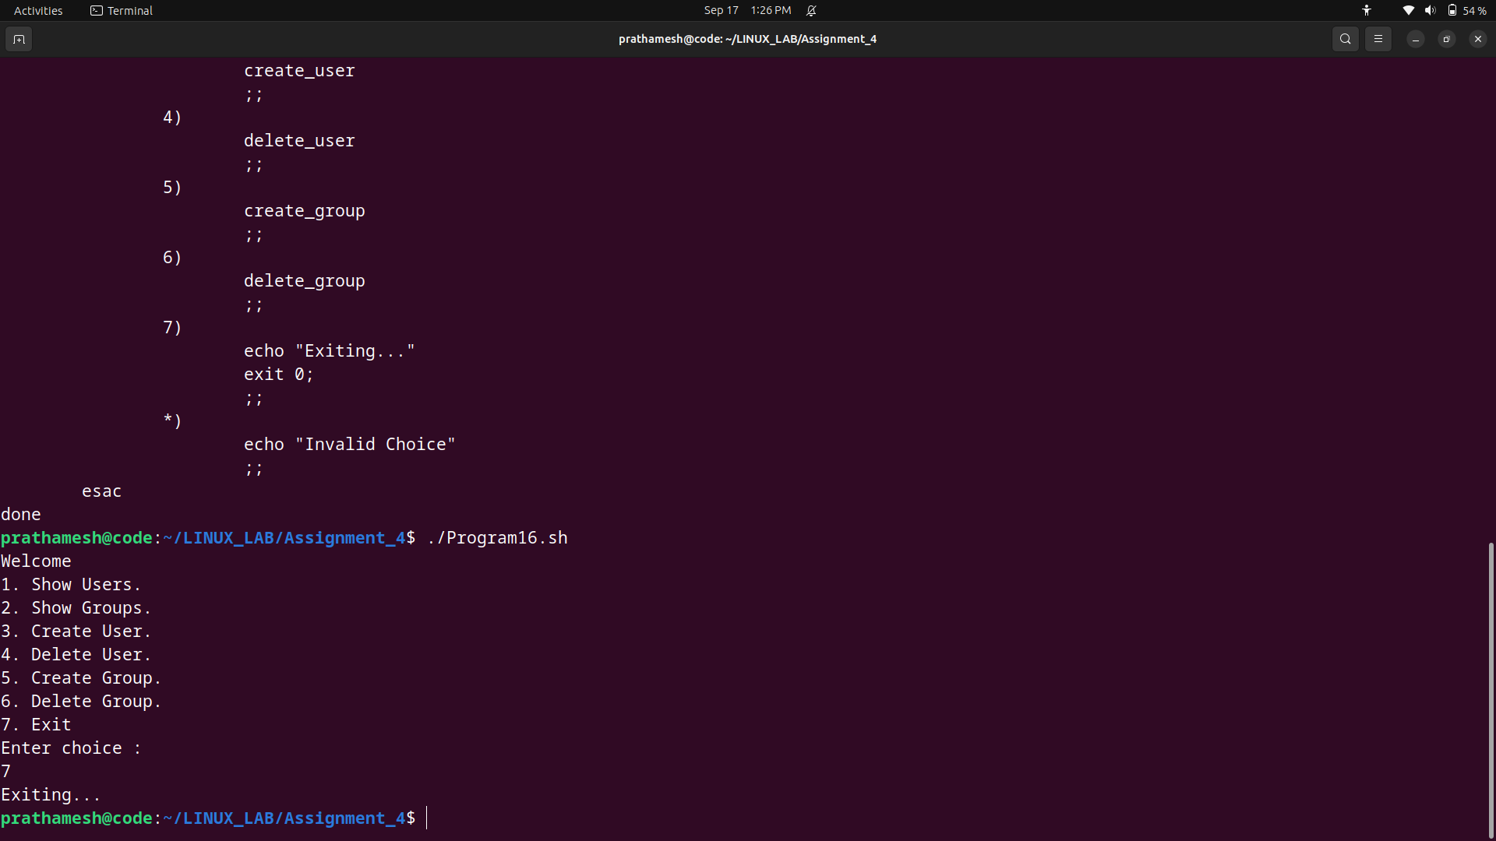

17. Shell Script to compute the sum of the first 10 natural numbers.

Expected Output :

The first 10 natural number is :

1 2 3 4 5 6 7 8 9 10

The Sum is : 55

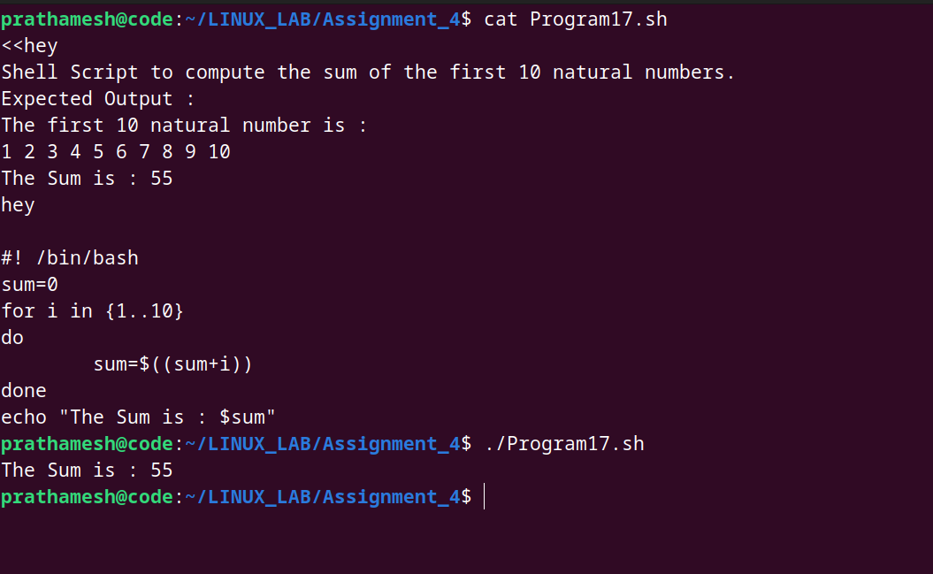

18. Shell Script to display n terms of natural numbers and their sum.

Test Data : 7

Expected Output :

The first 7 natural number is :

1 2 3 4 5 6 7

The Sum of Natural Number upto 7 terms : 28

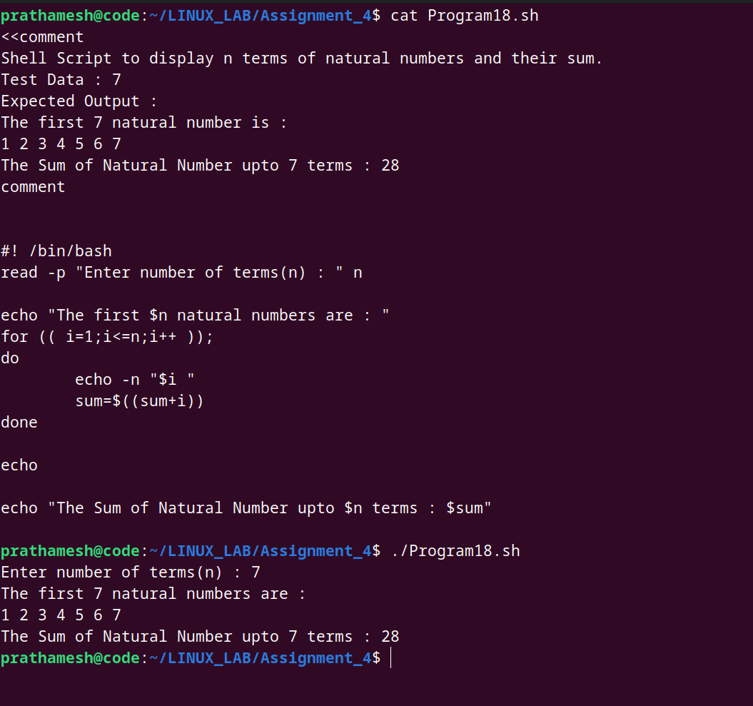

19.Shell Script to read 10 numbers from the keyboard and find their sum and average.

Test Data :

Input the 10 numbers :

Number-1 :2

...

Number-10 :2

Expected Output :

The sum of 10 no is : 55

The Average is : 5.500000

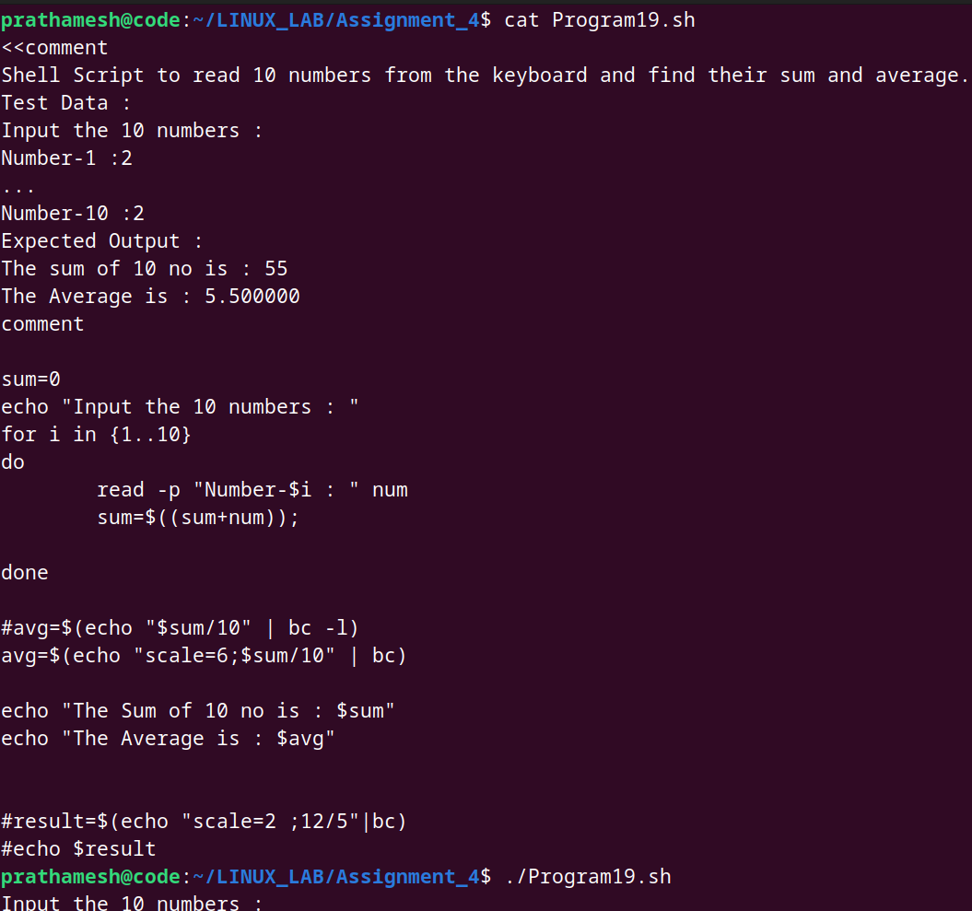

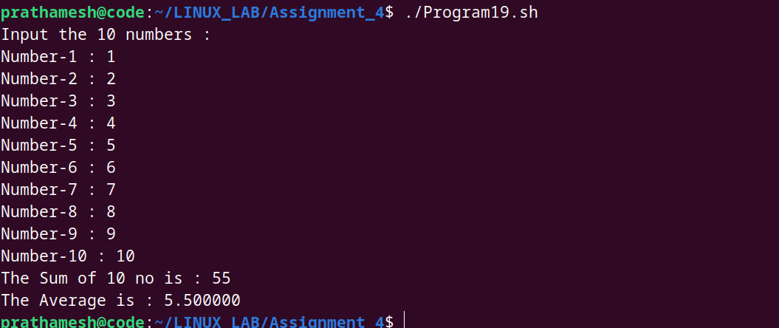

20. Shell Script to display the cube of the number up to an integer.

Test Data :

Input number of terms : 5

Expected Output :

Number is : 1 and cube of the 1 is :1

Number is : 2 and cube of the 2 is :8

Number is : 3 and cube of the 3 is :27

Number is : 4 and cube of the 4 is :64

Number is : 5 and cube of the 5 is :125

